


Field Report:
San Marino
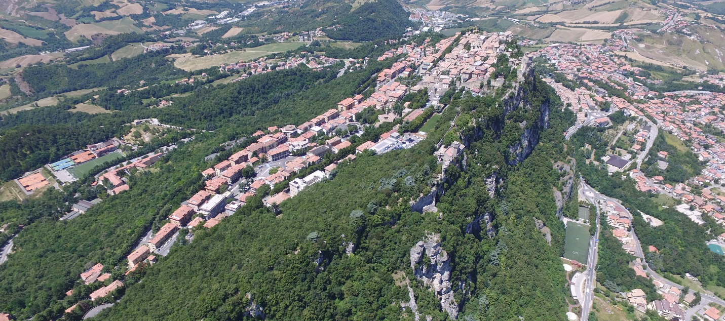

Dominique Meyer, Eric Lo, Sabrina Trinh, Emily Zheng, Gianmarco Guerra, Daniele Mina
Prof. Falko Kuester, Dr. Davide Forcellini

Objective
The long-term objective of this project is to demonstrate the creation of a comprehensive basemap (a digital surrogate) for the UNESCO heritage site in San Marino, using airborne imaging. UNESCO has identified a core site (55 hectares) and a buffer zone (167 hectares) surrounding it. In addition to the basemap, we would like to demonstrate high-quality, verified data acquisition for a collection of monuments, including its three towers and if time allows the Palazzo Publico and Basilica Di San Marino. We would like to eventually grow the base map to cover the entire state (61 km^2).

UNESCO Site: http://whc.unesco.org/en/list/1245/multiple=1&unique_number=1535
UNESCO Site Map: http://whc.unesco.org/document/101174

Short-term (July 2016 Expedition)
Initial focus will be on developing digital surrogates for the three towers, the Palazzo Publico, Basilica di San Marino and the Parva Domus. The goal is to geo-spatially connect them, creating the first step towards the base map of the larger San Marino cultural heritage reconstruction.

Toolbox

UAVs:
- DJI Phantom 3 Pro (P3P1)
- DJI Phantom 3 Pro (P3P2)

LIDAR:
- FARO Focus3D

Photography:
- CAVEcam
- Canon 5D M2
- Nikon D810

Data Structure

1torre- First Tower of San Marino (Guaita)
2torre- Second Tower of San Marino (Cesta)
3torre- Third Tower of San Marino (Montale)
church- Basilica of San Marino
palazzo- Palazzo Publico
parva- Parva Domus Comunis
sm- San Marino Village and Hill

_lidar- LIDAR scans
_sfmg- Ground SFM
_sfma- Aerial SFM
_cavecam- Stereo
_mediap- Media Photos
_mediav- Media Videos
_mediaa- Media Audio

Media images- 1,483 Images

Media videos- 266 videos

Ground SFM Images- 21,124 images
Aerial SFM Images- 7,883 images

Aerial Photogrammetry of Mt. Titano
Using a DJI Phantom 3, 1681 images were captured via manual flight mode on July 14th 2015, and another 125 captured 2 days later on the 16th.
This data is published on OpenHeritage3D
Eric Lo , Dominique Meyer , Emily Zheng , Sabrina Trinh , Davide Forcellini , Gianmarco Guerra , Cultural Heritage Engineering Initiative (CHEI) 2023: Mount Titano - Photogrammetry - Aerial . Collected by . Distributed by Open Heritage 3D. https://doi.org/10.26301/296p-dn53

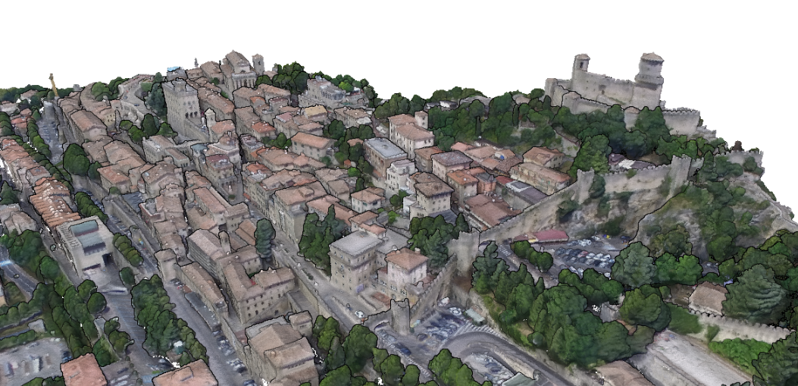

Tower 1 (Guaita)

The first and largest of the three towers of San Marino is also the oldest. It was built directly on bedrock using sandstone blocks, without a formal foundation, and features a pentagonal base. Dating back to the 10th century, it has been reinforced multiple times throughout history. The tower was rebuilt in the second half of the 15th century, and in the 16th century, it was covered with a sloping roof. It is known as the “Guaita,” and its solid rock walls are protected by double walls. The external surrounding wall, featuring merlons and truncated towers at the corners, encloses the tower and contains the Santa Barbara Church, which was built in 1960. The internal surrounding walls are the oldest and are bounded by the “Torre della Penna” and a smaller tower called the “Torre Campanaria.” This tower housed a bell that historically warned citizens to defend the country in times of danger. Inside the internal walls, there is also a building that was once used as accommodation for guards; later, it served as a prison.
Data Collected:
A multi-modal scan was performed of the Cesta, including terrestrial lidar and photogrammetry, and aerial drone. The dataset includes 31 lidar scans, 707 drone images, and 2277 terrestrial images.
These data are published to OpenHeritage3D.org
Eric Lo , Dominique Meyer , Emily Zheng , Sabrina Trinh , Davide Forcellini , Gianmarco Guerra , Cultural Heritage Engineering Initiative (CHEI) 2023: La Cesta - Photogrammetry - Aerial , LiDAR - Terrestrial , Photogrammetry - Terrestrial . Collected by . Distributed by Open Heritage 3D. https:/ /doi.org/10.26301/2h6g-jz80
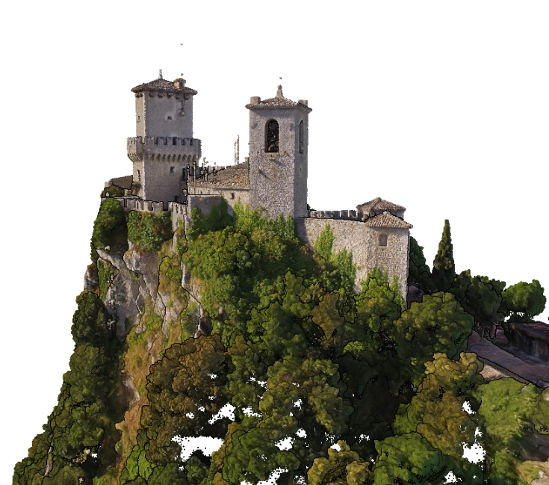

Tower 2 (Cesta)
Cesta Tower stands on the highest summit of Mount Titano, at an elevation of 756 meters. It was built at the end of the 11th century and features the characteristic pentagonal floor plan, constructed with sandstone blocks. Like the first tower, its primary purpose was to observe and detect the arrival of enemies approaching the settlement. In 1320, a high surrounding wall was built, serving as a secondary line of defense for the city. The second tower housed the Fortification Guards Division as well as some prison cells. By the late 16th century, when the tower was no longer of strategic importance, it fell into disuse. In 1930, following the construction of the Rimini–San Marino railway, it was decided to restore the medieval monuments to promote tourism. Today, Cesta Tower houses the Museum of Archaic Arms, which displays weapons from various periods, from the Middle Ages to the end of the 1800s.

In the first room on the ground floor, there are sidearms, with a ceiling supported by wooden beams and walls made of natural stone. The second room contains helmets and armor. The third room, with a wooden roof supported by stone columns, exhibits many crossbows and shields. On the second floor, there are weapons from the 16th and 17th centuries. At the same level, there is a balcony overlooking the tower. To the right of the tower, there is a small bell tower and a short, pentagonal lookout tower for surveying the valley.

Data Collected:
A multi-modal scan was performed of the Cesta, including terrestrial lidar and photogrammetry, and aerial drone. The dataset includes 31 lidar scans, 707 drone images, and 2277 terrestrial images.
These data are published to OpenHeritage3D.org
Eric Lo , Dominique Meyer , Emily Zheng , Sabrina Trinh , Davide Forcellini , Gianmarco Guerra , Cultural Heritage Engineering Initiative (CHEI) 2023: Mount Titano - Photogrammetry - Aerial . Collected by . Distributed by Open Heritage 3D. https://doi.org/10.26301/296p-dn53
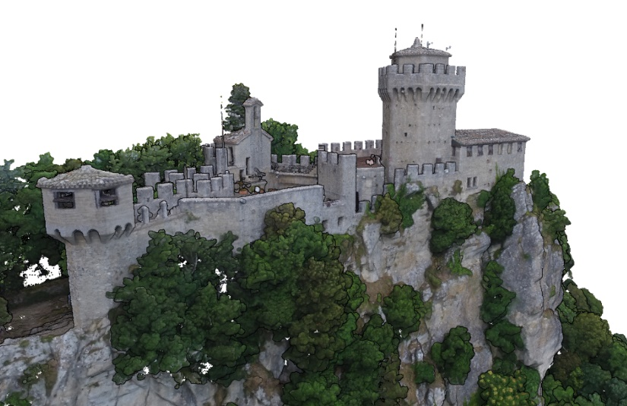

Tower 3 (Montale)
Montale Tower dates back to the end of the XIII century. It is the smallest tower, and because of it optimal position for a look-out post, it played a strategic role for defensive purposes. Especially in the past in the fight with “Malatesta” another italian family of Verucchio who have the Fiorentino castle. In the top of the tower there was a belt for warned citizens to the arrival of wayfarers who were asked a toll. When the Fiorentino castle was destroyed the tower was disused. The fortress, with its pentagonal floor plan, was built with sandstone block and has been restored on numerous occasions during the course of the centuries. The last restoration took place in 1935. Inside, there is a prison 8 meters deep, called “the bottom of the tower” who is accessible only by the top. The main entrance of the tower was at about eight meters from the ground and for reach it in the past some iron step were inserted in the wall. Montale is surrounded by very large rocks arranged to form a primitive wall structure. In particular the wall who connect the second tower with the third tower who are visible still now.

Data Collected:
A multi-modal scan was performed of the Montale, including terrestrial lidar and photogrammetry, and aerial drone. A first set of exterior and interior scans were performed on July 14th 2016, with a scaffold in place to enable access to the tower interior. Later, on July 17th, another set of exterior scans were performed wihtout this scaffold, giving an unobfuscated view of the whole tower. The dataset includes 31 lidar scans, 1543 drone images, and 1789 terrestrial images.
This data is made available through OpenHeritage3D.org
Eric Lo , Dominique Meyer , Emily Zheng , Sabrina Trinh , Davide Forcellini , Gianmarco Guerra , Cultural Heritage Engineering Initiative (CHEI) 2023: La Montale - Photogrammetry - Aerial , LiDAR - Terrestrial , Photogrammetry - Terrestrial . Collected by . Distributed by Open Heritage 3D. https://doi.org/10.26301/sebe-xm37
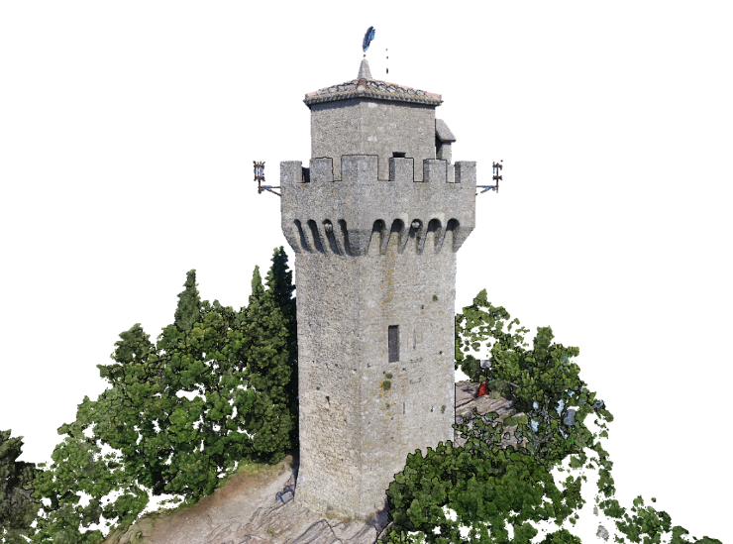

Palazzo Publico
Palazzo Pubblico is San Marino’s town hall and official Government Building. Official State ceremonies are hosted at the Palazzo Pubblico. In addition it is the seat of the Republic main institutions, including the Captains Regent, the Grand and General Council, the Council of XII, and the Congress of State. Located on the site of an ancient building called the Domus Magna Communis, and built in the end of XIV century was destroyed and rebuilt, the current building was designed by the architect Francesco Azzurri between 1884 and 1894. After a hundred years of existence, a complex restoration project was undertaken. The renovation was completed by the architect Gae Aulenti on 30 September 1996. The front of the palace have many symbols of the Republic and the four castle: Serravalle,Fiorentino, Montegiardino e Faetano there are also three arch and a polygonal balcony between two large windows. On the left side of the palace there are a belfry with the images of the three saint of San Marino: Sant’Agata, San Marino e San Leo and a clock. Inside the palace there are a large lobby where are a lot of trophy, inscriptions and busts of famous men. At the first floor with a staircase there are the main room called “Aula del Consiglio” where they met the sixty member of parliament have a meeting since 1848. There are also many room of the Captains Regent and of the Council. Under the square in front of the palace there are the tank of the rain, who is used by the people of San Marino like a hydro-supply.

Data Collected:
A multi-modal scan was performed of the Palazzo Pubblico and the surrounding streets, including terrestrial lidar and photogrammetry, and aerial drone. The dataset includes 69 lidar scans, 1327 drone images, and 2818 terrestrial images. Exterior LiDAR scans of the Piazza were performed at night, so no rgb data is available.
These data are available for download through OpenHeritage3D.org
Eric Lo , Dominique Meyer , Emily Zheng , Sabrina Trinh , Davide Forcellini , Gianmarco Guerra , Cultural Heritage Engineering Initiative (CHEI) 2023: Palazzo Pubblico and Piazza della Liberta - Photogrammetry - Aerial , LiDAR - Terrestrial , Photogrammetry - Terrestrial . Collected by . Distributed by Open Heritage 3D. https://doi.org/10.26301/89td-rv98
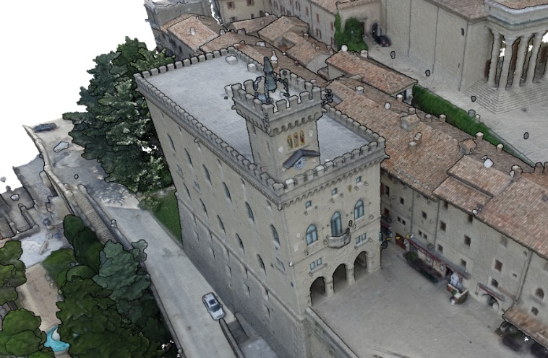

Parva Domus
The “Parva Domus” is located in the center of the city of San Marino in front of the Palazzo Pubblico on the square of the Liberty. It’s an historical building, mentioned in documents dating 1353 and 1378 and probably is the first palace assigned for public purpose in the City of San Marino. It was the place where the Captains Regent used to reside in the days of public hearing, while in the building opposite, the "Domus Magna Comunis" built after the Parva Domus, were located the Arengo assemblies (meeting of the household) and the Council. Some years ago, it became the seat of the Secretariat of State for Internal Affairs. It’s closed to the public.

Data Collected
These data are restricted due to the sensitive nature of their subject. For questions regarding this data please contact dronelab@ucsd.edu
The dataset contains:
15 terrestrial lidar scans
388 aerial images
273 exterior photos
37 interior photos (lobby only)

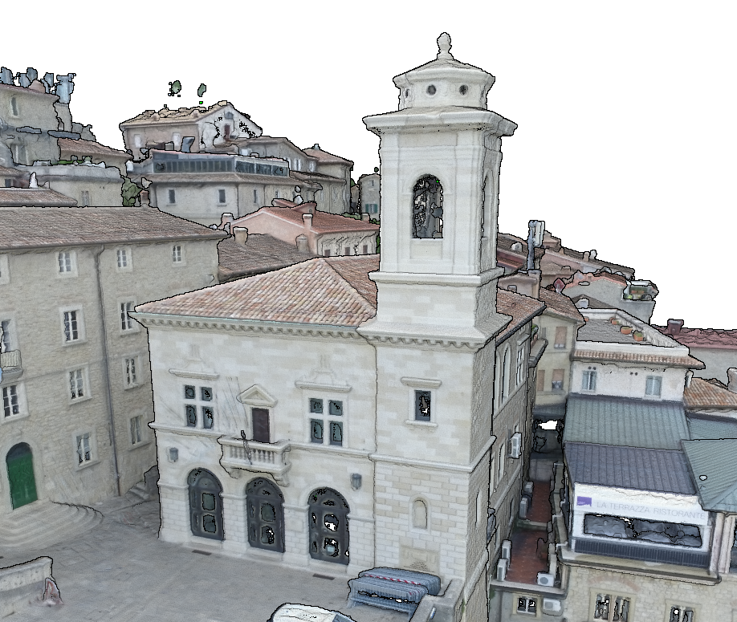

Basilica di S. Marino
The Basilica of San Marino is the main church of the city of San Marino and it’s in honor of the saint of the same name of the city and It’s located in the Square “Domus Plebis”. In the same place in the past it was a smaller church dedicated to San Marino deacon built in the 530. At the beginning of the 1800s, the church was in critical condition. In 1807, it was razed and a project for the construction of the new church was handed to Antonio Serra from Bologna. On 24 July 1825, the council decided to build a new church in the place where the old church had stood. Construction began on 28 July 1826 and was completed in 1838. On 5 February 1855, the church was solemnly inaugurated. On 21 July 1926, it was elevated to the rank of Basilica by Pius XI. The inside of the Basilica has a neo-classic style and is consists of three naves, supported by sixteen Corinthian columns which form a large ambulatory around the semicircular apse. In the main façade there is, preceded by a staircase, a porch of eight columns, six at the front and two either side, with a latin inscription written above it which reads "DIVO. MARINO. PATRONO. ET. LIBERTATIS. AVCTORI. SEN. P. Q." The massive bell tower, originally in Romanic style, was rebuilt in the 1600’s. Internally, the Basilica has three aisles and seven altars. The throne of the Regents, dating to the 1600’s, is situated to the left of the main altar; under the altar a small urn contains the bones of St. Marino

Data Collected:
A multi-modal scan was performed of the Basilica di San Marino and neighboring Church of St. Peter including terrestrial lidar and photogrammetry, and aerial drone. The dataset includes 42 lidar scans, of the exterior, interior, and attic spaces, 925 drone images, and 2664 terrestrial images.
These data are available here:
Eric Lo , Dominique Meyer , Emily Zheng , Sabrina Trinh , Davide Forcellini , Gianmarco Guerra , Cultural Heritage Engineering Initiative (CHEI) 2023: Basilica di San Marino and Chiesa di San Pietro - Photogrammetry - Aerial , LiDAR - Terrestrial , Photogrammetry - Terrestrial . Collected by . Distributed by Open Heritage 3D.
https://doi.org/10.26301/shvk-8173
