POSER: an oPen sOurce Simulation platform for tEaching and tRaining underwater photogrammetry

Fabio Menna ¹, Scott McAvoy ², Erica Nocerino ³, Beatrice Tanduo ⁴, Louise Giuseffi ⁵, Alessio Calantropio ³, Filiberto Chiabrando ⁴, Lorenzo Teppati Losè ⁴, Andrea Maria Lingua ⁵, Stuart Sandin ⁷, Clint Edwards ⁷, Brian Zgliczynski ⁷, Dominique Rissolo ², Falko Kuester ²

¹ Department of Chemical, Physical, Mathematical and Natural Sciences, University of Sassari, Sassari, Italy – fmenna@uniss.it
² University of San Diego California, Cultural Heritage Engineering Initiative (CHEI), La Jolla, CA, USA – (fkuester; smcavoy; drissolo)@ucsd.edu
³ Department of Humanities and Social Sciences, University of Sassari, Sassari, Italy – (enocerino; acalantropio)@uniss.it
⁴ Department of Architecture and Design, Politecnico di Torino, Torino, Italy – (filiberto.chiabrando; lorenzo.teppati; beatrice.tanduo)@polito.it
⁵ National Oceanic and Atmospheric Administration, Southwest Fisheries Science Center, La Jolla, CA, USA – louise.giuseffi@noaa.gov
⁶ Department of Environment, Land and Infrastructure Engineering, Politecnico di Torino, Torino, Italy – andrea.lingua@polito.it
⁷ University of San Diego California, Scripps Institution of Oceanography, La Jolla, CA, USA – (ssandin; clint; bzgliczy)@ucsd.edu

Keywords: Underwater photogrammetry, Open Source, simulation platform, capacity building.

Abstract

Underwater photogrammetry presents unique challenges due to the optical properties of water that, if not correctly taken into account, might affect the quality of the survey and the related 2D and 3D products. There is a clear need to train new surveyors in this field, and to strengthen the capacity-building capabilities of the international photogrammetry and remote sensing community. Starting from this consideration, we propose the development of POSER, a 3D simulation framework designed to facilitate the teaching of underwater imaging principles. The project, an ISPRS Educational and Capacity Building Initiative, is built upon the open-source platform Blender, incorporating realistic modelling of water physical properties, including light refraction, scattering, and absorption phenomena, to simulate underwater surveying conditions. We foster a learning-by-doing approach, providing users with ready-to-use application scenarios inspired by real-life case studies. They will cover a range of application fields, from marine ecology to archaeology and subsea metrology and allow users to address the complexities of underwater surveying practices. This paper introduces POSER to the community, presenting its educational vocation and describing its constituent components.

Introduction

A simulation software for teaching underwater photogrammetry
Underwater photogrammetry has become an essential technique for studying and understanding the underwater world in many application fields, such as exploration and mapping, industry and metrology, engineering, archaeology, ecology, etc. Nevertheless, producing accurate three-dimensional measurements underwater is still a challenge if compared to photogrammetric applications on land.

In this paper, we present the development of POSER, a 3D simulation framework with the educational mission of supporting the teaching of underwater photogrammetry. Through the generation of computer-aided teaching and learning material, POSER will help the comprehension of the physical properties of the underwater environment with its challenges, hereafter briefly described:

Water, especially seawater, is characterized by a high electrical conductivity, requiring electronic apparatuses and imaging sensors to be enclosed in a waterproof housing, mounting an optically transparent interface, usually shaped in the form of a flat or hemispherical port. The water and the ports of the housing affect the image formation, possibly introducing, among others, aberrations and distant-dependent geometric distortions.

The design of the camera housings and ports, in terms of mechanical and optical characteristics, is mainly ruled by the high density of water, approximately 800 times greater than air, which requires the enclosure to be properly dimensioned to withstand the significant forces exerted by the water pressure over its shell as the depth increases.

The refractive index of water varies as a function of temperature, salinity, pressure, and light wavelengths, thus requiring the imaging system to be optically calibrated for specific operative conditions.

The presence of suspended particles due to organic and inorganic matter, such as phytoplankton, sediment, or pollution, causes scatter and backscatter phenomena that reduce water clarity. The wavelength-dependent absorption of light produces color distortions that are a function of both water depth (when ambient sunlight is available), distance from the camera and from the artificial light sources.

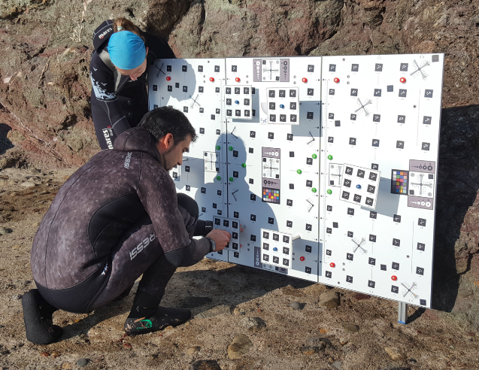 | 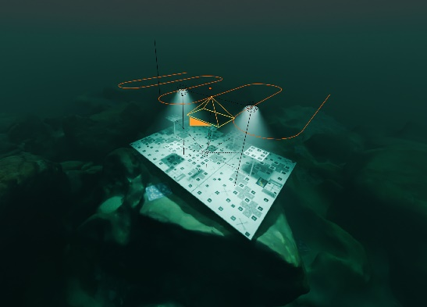 | 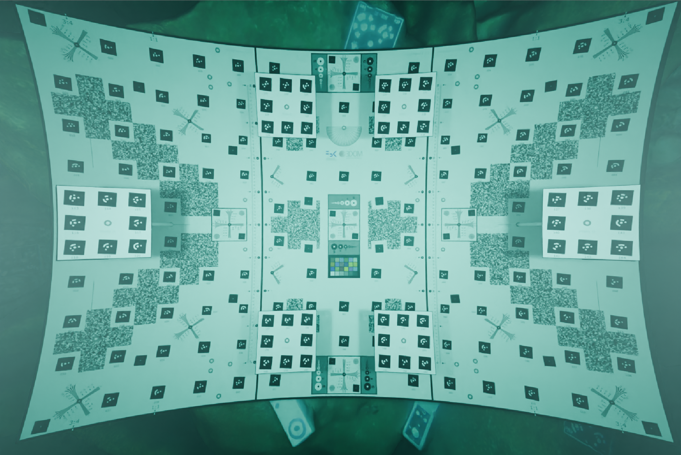
Figure 1. The ISPRS POSER project will use a mix of reality-based and simulated underwater environments to support teaching the main aspects and challenges encountered in underwater photogrammetry. A calibration test-object (left, Menna et al., 2017) is virtually inserted in an underwater 3D scene in Blender (center and right) to simulate an underwater calibration of a camera enclosed in a waterproof housing mounting a flat port. The simulated images are generated using a physically based ray-tracing approach that can accurately simulate physical phenomena such as refraction, scattering, backscattering, and volumetric absorption. The resulting image (right) shows heavy pincushion radial distortions and a bluish color dominant.

The height of the sun, depending on the location on Earth, time of day and season, and the sea conditions, influences the actual amount of light that is refracted, absorbed, or reflected upward. Scatter, backscatter, and wavelength-dependent light absorption reduce the amount of light reaching the underwater environment. Light is more absorbed in rough seas, whereas it is highly reflected in calm waters that act as a mirror surface.

Light rays are refracted by wavy surfaces, producing bright patterns known as caustics. These patterns are unfavorable for photogrammetric applications because they could affect the automatic extraction of 2D features in images and produce poor-quality object texture. The intensity of light caustics depends on sun elevation, water turbidity, and depth, with the effect significantly reduced after a few meters’ depth (Floor, 2005).

A broad technical literature exists on the physical properties of water and its influence on image formation for underwater photogrammetry applications (Morel, 1974; Jaffe, 1990; Bryson et al., 2013). However, these resources can be overwhelming and challenging for new practitioners, especially those with limited technical background. For the above reasons, novel teaching paradigms are increasingly in demand. These may leverage advanced digital technologies, such as computer simulations, augmented and virtual reality, and game-based learning approaches, to cite a few.
In recent years, the potentialities of simulation platforms have become increasingly evident both for research purposes (Nakath et al., 2022; Zwilgmeyer et al., 2021; Wang et al., 2019) and for educational goals (Luhmann et al., 2022). Among the different reasons, we can include the possibility of simulating environments that are difficult to access, performing a statistically significant number of tests, lowering costs, and systematically varying and controlling the different variables involved. Still, simulation solutions present limitations, as evidenced by the fact that they remain a very active research topic. At the same time, these solutions have undeniable potential in the educational context or in cases where researchers and practitioners have limited access to real-world resources.

Objective and goals of the POSER project
The aim of POSER, an ISPRS-funded Education and Capacity Building Initiative, is to build an educational simulation platform as a means to create a learning environment for students and practitioners. In this frame, idealized scenarios and datasets for underwater photogrammetry will enable the users to actively learn surveying skills and best practices by isolating relevant variables within a closed environment. So, while the project primarily pursues educational purposes, it will also contribute to improving simulation platforms applied in research contexts.

Working in a cross-disciplinary team of geomatics experts, oceanographers, archaeologists, data analysts, and instructional designers, we have devised a highly versatile empirical framework to test and compare the standard methods used in large-scale underwater structure from motion (SfM) and multi-view stereo (MVS) reconstruction, to help establish and communicate best practices, and to educate the community regarding the fundamental principles at play and demonstrate the effects of improper planning and data acquisition strategies. We employ a customizable open-source digital simulator, made publicly available, with the goal of beginning the communal, cross disciplinary development of rigorous standards for field-captured data.

POSER will use a mix of reality-based and simulated underwater environments to cover the main aspects and challenges encountered when planning and executing underwater photogrammetry surveys. The results of these simulations produce experimental image datasets (Figure 1) which can be used to help understanding basic underwater imaging concepts, such as ground sample distance (GSD), image overlap and side lap, artificial lighting configuration to name a few. These datasets can then be processed using different photogrammetric software solutions and analyzed to show and compare differences in the achievable potential accuracy.

The rest of the paper explains the POSER simulator's main functionalities, along with preliminary results and relevant examples from different underwater application fields.

POSER simulator in BLENDER
A preliminary project of an underwater simulator was implemented in Blender to plan and analyze common camera networks utilized by NOAA, National Parks Service, and Scripps Institution of Oceanography researchers (Figure 2, Giuseffi 2020). The simulator shows the camera's movement over a scene in real-time, with an adjacent view of the camera’s local view. The rendered images are then processed in an SfM+MVS application, allowing a straightforward comparison of the 3D reconstructions. POSER builds upon this first experience, adding rigorous yet flexible modelling of water-air-glass interfaces in Blender (Nakath et al., 2022). This component is necessary for assessing the impact of residual systematic errors

a) | b)
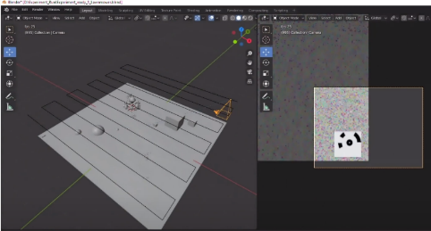 | 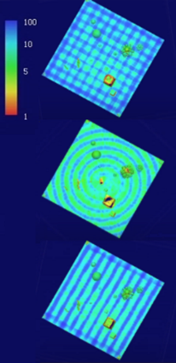
Figure 2. A preliminary version of the POSER simulator in Blender shows the 3D scene and the moving camera input (a) in a side-by-side view, as well as Agisoft Metashape point confidence values (b), after processing the images of the same synthetic environment with varying acquisition patterns (lawnmower with parallel and cross strips, spiral strip, parallel strips).

introduced by non-centered dome ports and flat ports (Menna et al., 2020; Nocerino et al., 2021; She et al., 2022; Rofalski et al., 2022), and extending the analyses to optical aberrations such as field curvature with dome ports and astigmatism with flat ports (Menna et al., 2016, 2017). In POSER, an extension to cylindrically shaped ports is also introduced.

The reasons behind choosing Blender (www.blender.org) as simulation platform are manifold.
Blender is a free and open-source 3D computer graphics software tool set used for different purposes such as film animation, modelling, art, 3D printing, texturing, motion graphics, simulations, and interactive 3D applications. Based on an OpenGL GUI interface, it is cross-platform, running on Linux, macOS, and Windows systems. It is highly customizable featuring an extensive python API scripting that can control any tool available in the software. Moreover, it is supported by an active community worldwide with countless tutorials and examples available on the internet.
Blender offers different rendering engines, among which the Cycles engine provides realistic physically based rendering (PBR), volumetric rendering with absorption, scattering, subsurface scattering, support for different camera models from rectilinear to fisheye, depth of field, motion blur, different lighting models. Though Blender, with its multitude of options and interfaces, can be quite daunting for new users be, POSER will incorporate custom menu interfaces within this system, providing a simplified means to manipulate relevant parameters which might otherwise be scattered across many different menus. It will also take advantage of the Python scripting functionality enabling light-weight re-configuration and sharing of complex scenes. In this way an experimental model, composed of a great many individual variables, can be easily exported, reviewed, and replicated externally.

POSER will also leverage virtual reality (VR) functionalities available in Blender through the VR Scene Inspection add-on that exposes and extends the native virtual reality features of Blender in the user interface.
Multiple pre-designed scenarios (see Section XX) are envisaged in POSER to cover different fields, such as marine ecology, archaeology, and subsea industrial metrology. The application of VR will provide more immersive photogrammetry teaching and training sessions to reach and engage a broader audience. The compelling idea is to create applications that are accessible both "at home" and "in the classroom", enhancing the transfer of knowledge on best practices for underwater data acquisition. This trend is supported by the increasing availability of VR/AR/MR devices on the market and their growing adoption in various sectors, including education, scientific research and tourism. Furthermore, the use of these technologies offers numerous advantages, including the ability to simulate challenging environmental conditions safely and in a controlled manner, enabling the users to tackle complex challenges with greater effectiveness. The availability of VR/AR platforms for learning underwater photogrammetry allows reaching a wider and more diverse audience, facilitating the sharing of knowledge and collaboration among different communities interested in the documentation and conservation of underwater scenarios.

Simulated virtual scenes: different challenges from marine ecology to archaeology and subsea metrology
Whether by SCUBA diving or using an ROV, the time available for underwater operations is always limited, either because of decompression sickness (DCS) risks or the costs associated with support vessels and personnel needed for remote operations offshore. Therefore, underwater virtual environments envisaged in POSER can be used to optimize the design of image acquisition operations and train different aspects of underwater photogrammetry. Depending on the application field and the main goal of the photogrammetric survey, POSER will be used to simulate the different case studies and the associated environmental challenges. For example, in monitoring the growth and health of coral reefs, practitioners would need to plan an appropriate ground sample distance to fulfil the ecological analyses and design a proper camera network acquisition. Indeed, depending on the shape of the corals, standard aerial-like nadir-looking imaging networks may not be enough to fully model the 3D structural complexity of some coral species (Figure 3).

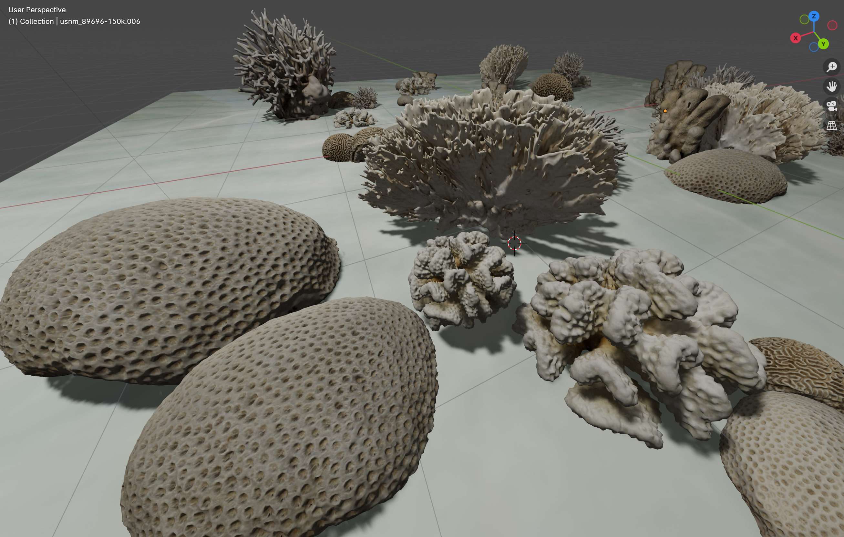 | 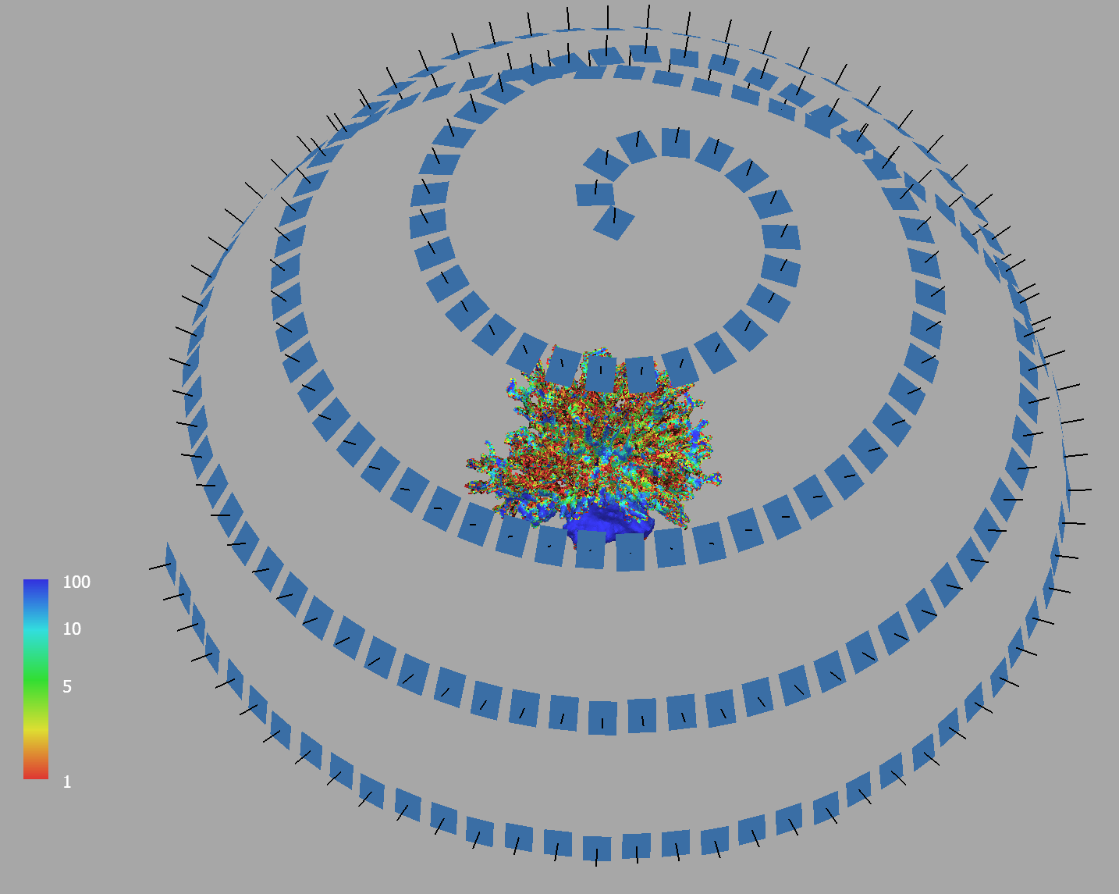 | 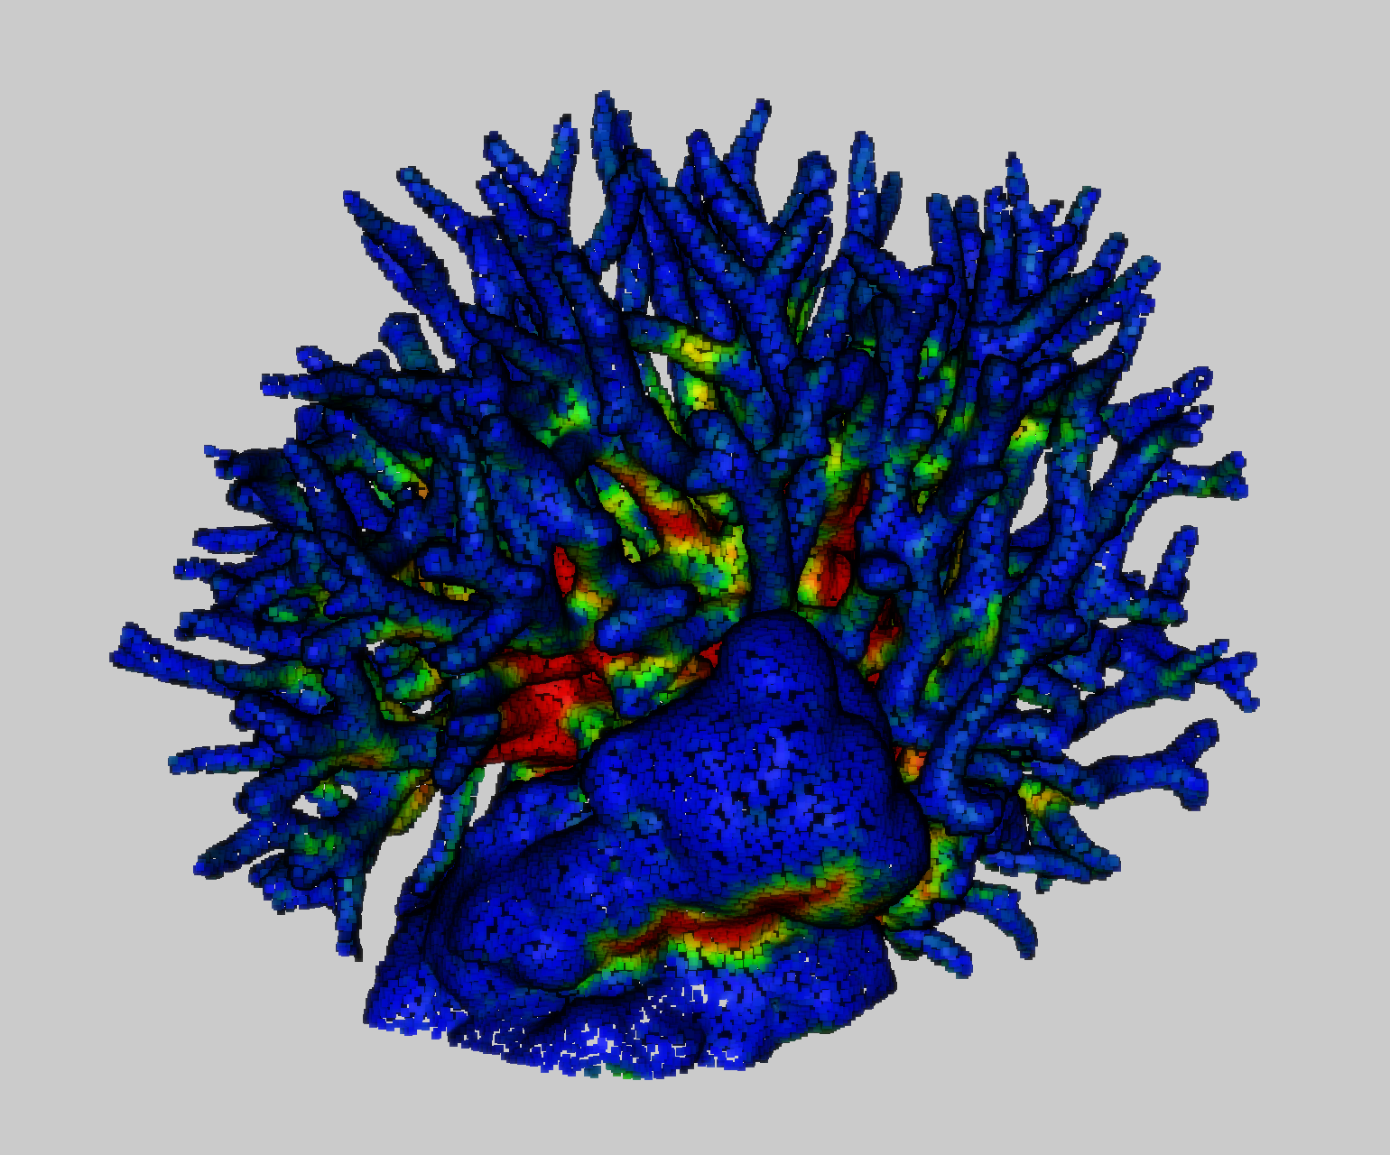
Figure 3. Virtual scene (left) built using 3D models of different coral species from the Smithsonian 3D digitization collection (https://3d.si.edu/corals) used in this example for teaching the different levels of surveying complexity associated with various coral species (e.g. branching corals vs massive). A seriatopora hystrix branching coral (middle and right) )is selected as case study to test different camera network configurations (a spherical spiral in the figure) and understand the level of completeness reached in the 3D reconstruction. Due to self-obstructions the red and green parts in the reference 3D model are not reconstructed in the photogrammetric 3D model.

In underwater archaeology, before beginning any excavation phase, it is necessary to provide a complete site plan and accurate photographic documentation; critical operations to decide how to proceed with the excavation (Calantropio et al., 2021). After delimiting the area, setting the origin of a stable reference system, and starting with the first phase of excavation, the excavated area is covered with a grid square (site gridding), allowing the division of the excavation area into smaller squares. Photogrammetric surveys are then repeated during the excavation phase. The most relevant challenges for photogrammetric acquisitions are suspended particles in the aftermath of the excavation, dive time associated with the depth of the site, and occlusions due to the size and shape of the assets. For the above reasons, it is clear how a simulation tool will help in understanding the constraints of the site beforehand, allowing for a reasoned acquisition step, reducing dive time, and increasing the safety of the involved operators.

In the Oil & Gas industry, subsea metrology is required to document and monitor underwater infrastructures or support building operations, for example, by accurately measuring underwater assets' relative position and orientation (pose). Typically working at great depths, in these scenarios, the survey operations are carried out in complete darkness and, often in turbid water, using an ROV. In these cases, POSER will be used to explain the peculiarities of these scenarios, simulating, for example, the waterproof housings with thick dome ports needed to withstand huge pressures.

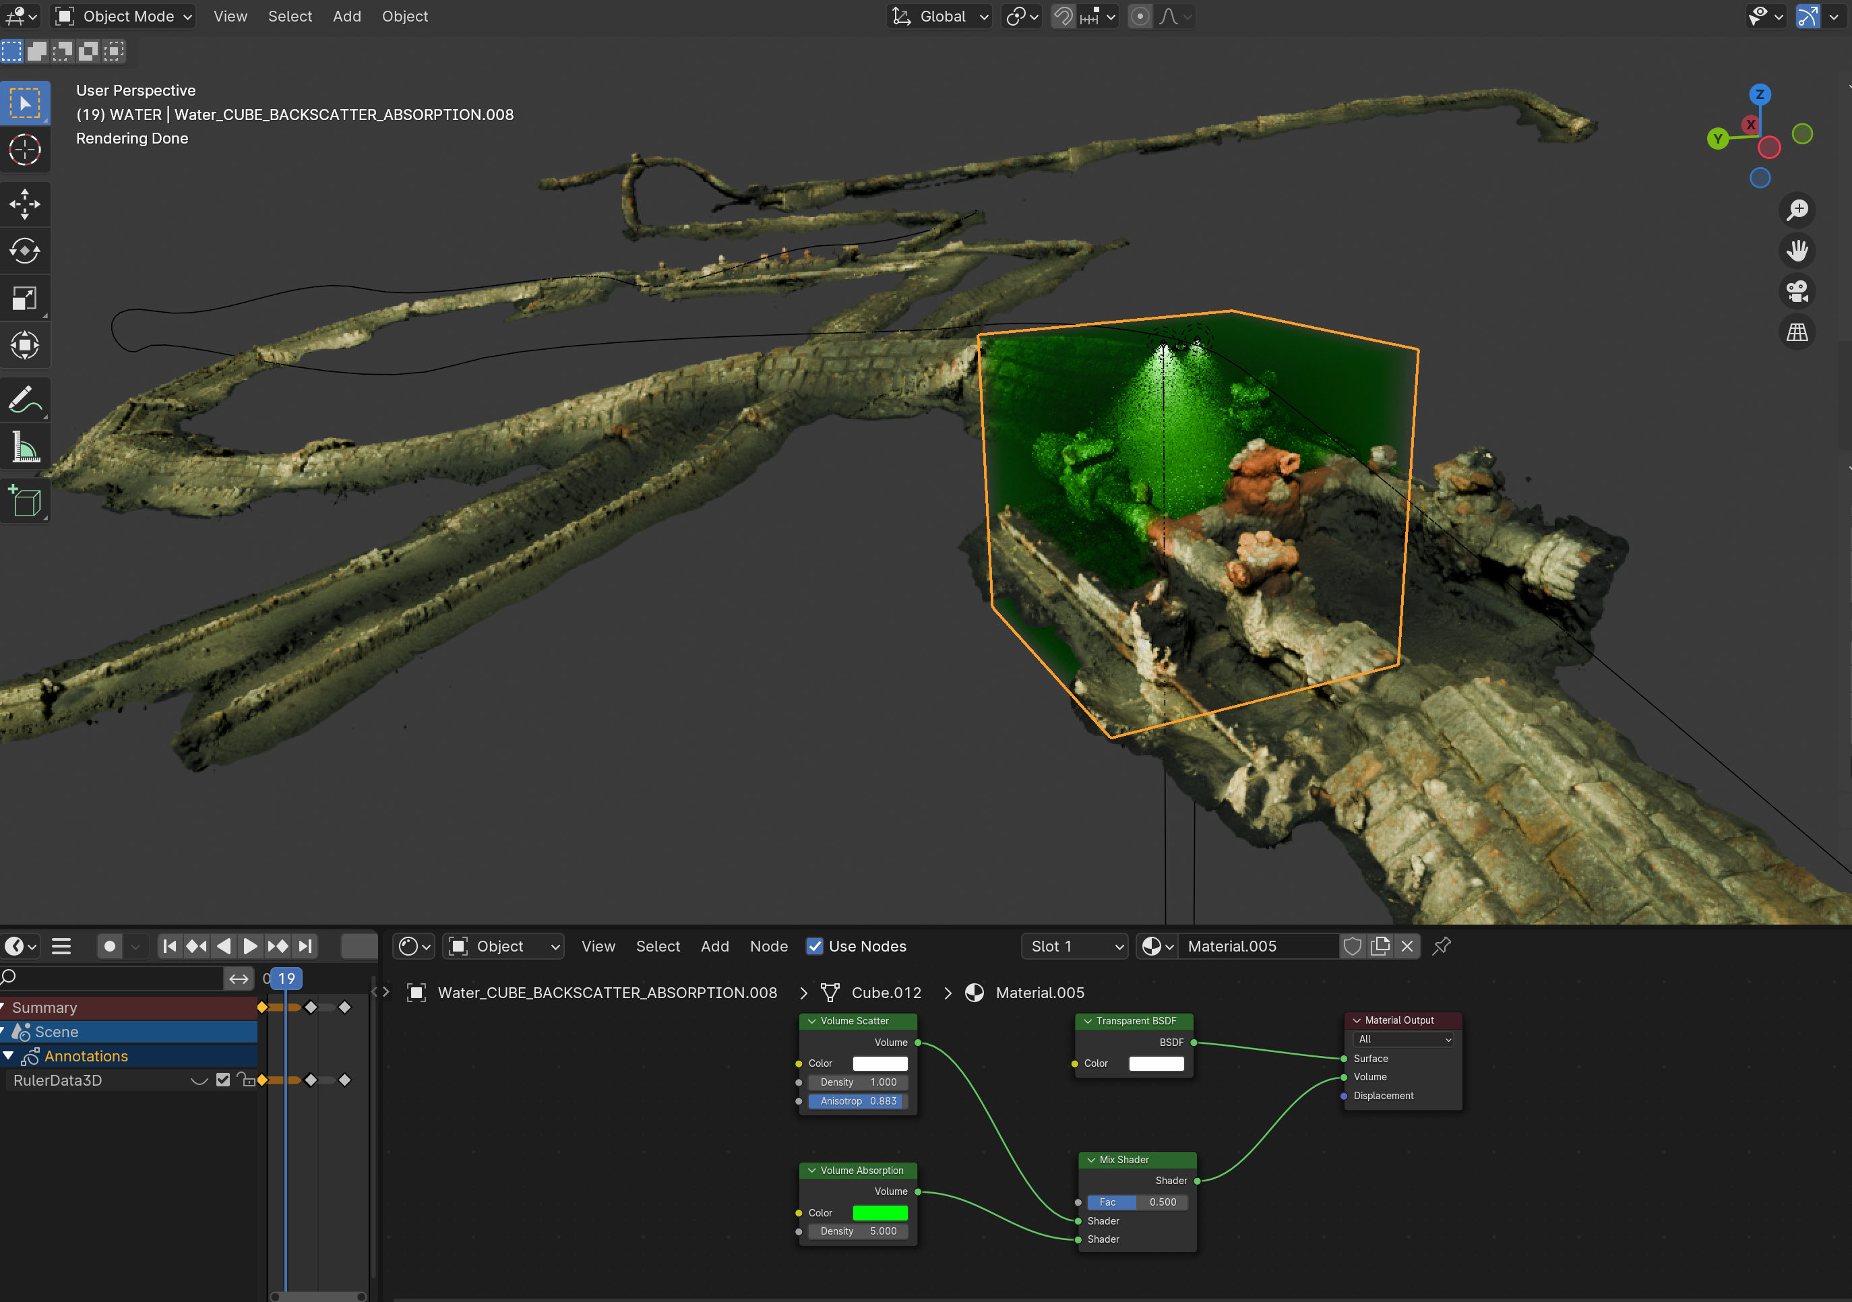

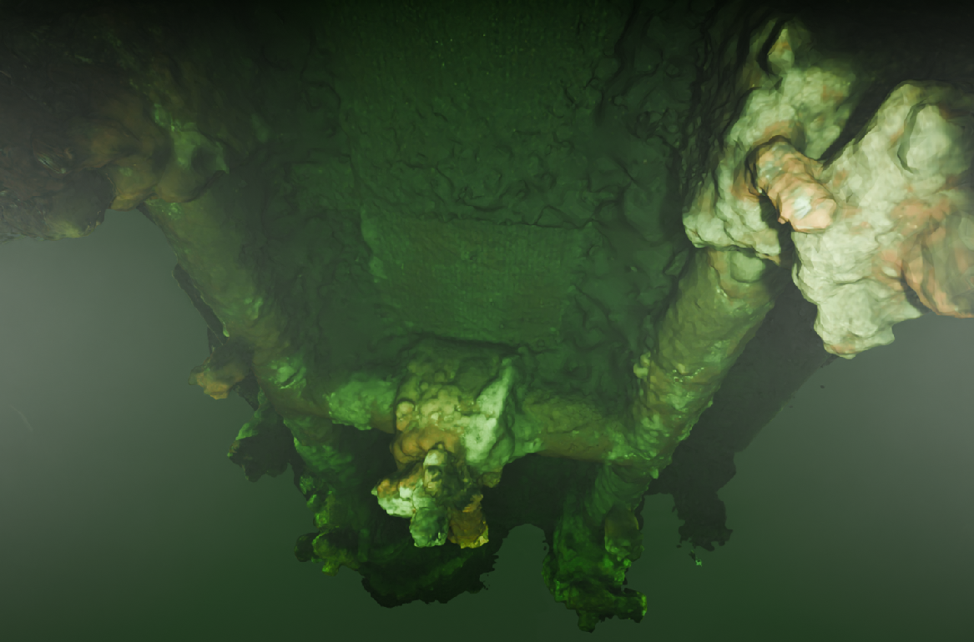

Figure 4. An example of subsea metrology scene in POSER where different lighting configurations, turbidity levels and geometry of the pressure housing ports can be tested. A cube around the camera used is introduced for rendering purposes, allowing testing volumetric scattering and absorption (above) in a more efficient way. The resulting image is characterized by limited visibility and a green strong color cast (below).

Also, it will aid in understanding the best lighting configuration to minimize backscattering in turbid waters and plan the proper camera network for 3D inspection, from complex structures to long pipes.
Figure 4 shows an example of a 3D model of a pipeline with a water volume only around the camera to improve the performances of the volumetric rendering.

Modelling the optical physics of the underwater environment

Refraction
The refractive effects introduced by water and the ports used in the waterproof housings are among the most important differences encountered in underwater photogrammetry with respect to terrestrial and aerial photogrammetry. These affect the geometry of recorded images and thus may strongly influence the accuracy of 3D measurements. Additionally, scatter, backscatter, selective wavelength light absorption, and light caustics (mainly in shallow waters) are other key optical and physical phenomena that must be understood before dealing with underwater photogrammetry surveys. In POSER, we start from the developments presented in GEODT (Nakath et al., 2022), where the raytracing approach used in the Cycles rendering engine was validated for dome and flat ports using a real laboratory tank and its 3D-modelled digital twin. Following this approach, a flat port underwater can be easily modeled in Blender by inserting a planar mesh surface between the camera and the 3D scene. A glass material shader is then given to the planar surface with an index of refraction (IOR) intended as the ratio between the medium in which the camera is located (air) and the next one encountered towards the object space. Therefore, if the thickness of the flat port is neglected, its the IOR will be 1/1.33 (1 for air and 1.33 for water). Conversely, two surfaces are introduced if the thickness is to be considered. For the first surface, going from air to glass, the IOR will be 1/1.52 (in case of a BK-7 optical glass); for the second surface, going from glass to water, the IOR will be 1.52/1.33 (Figure 3). Similarly, a dome port can be modeled using single or double concentric spherical surfaces. Virtually, with this approach any shape of the port can be considered. In POSER, we plan to add other port shapes, such as the cylinder, as it is often used in small micro ROVs for inspection (e.g., the Deep Trekker).
The presence of flat, dome, and cylindrical ports not only affects the geometry of projection, for example, introducing distortions, but they also influence the focusing (on a closer and smaller virtual image) and image quality in terms of aberrations, such as field curvature and astigmatism, which negatively impact the accuracy of image measurements (Menna et al., 2016, 2017). In POSER, we will provide the possibility of rendering the simulated images, including the optical aberrations caused by the different port shapes. Moreover, single, stereo, and multicamera configurations will be allowed to feature several lens projection models, such as rectilinear and fisheye lenses.

Since Blender does not model the chromatic aberrations, we render the synthetic images three times, one per each R,G,B channel, using the proper IORs (function of the different wavelengths). We then combine the three image channels in a RGB image as visible in Figure 5: a full frame camera mounting a 18 mm lens is virtually mounted in a waterproof housing and evaluated on a specifically designed test field (Menna et al., 2017) using three different ports, i.e. flat, dome and cylindrical.

Flat  (EP off the planar surface) | 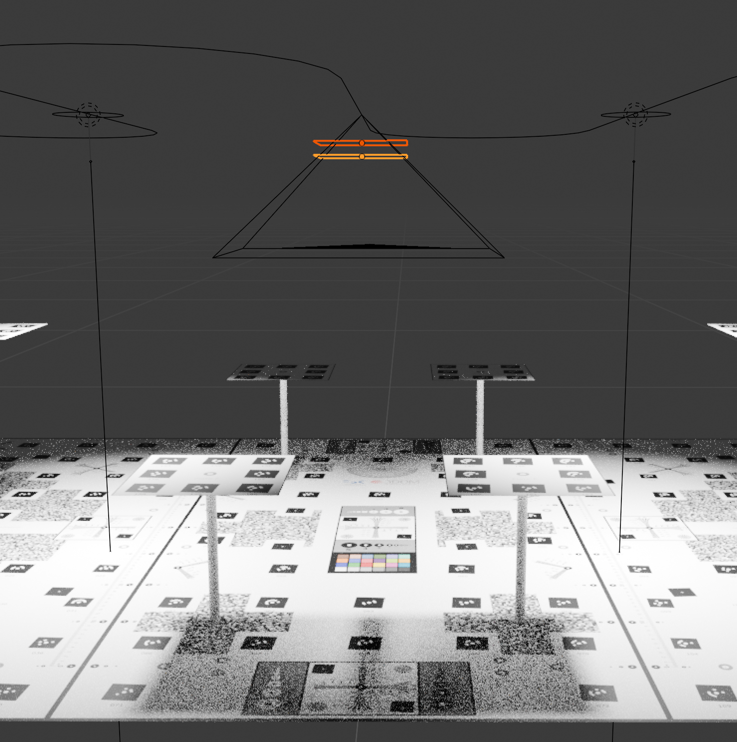 | 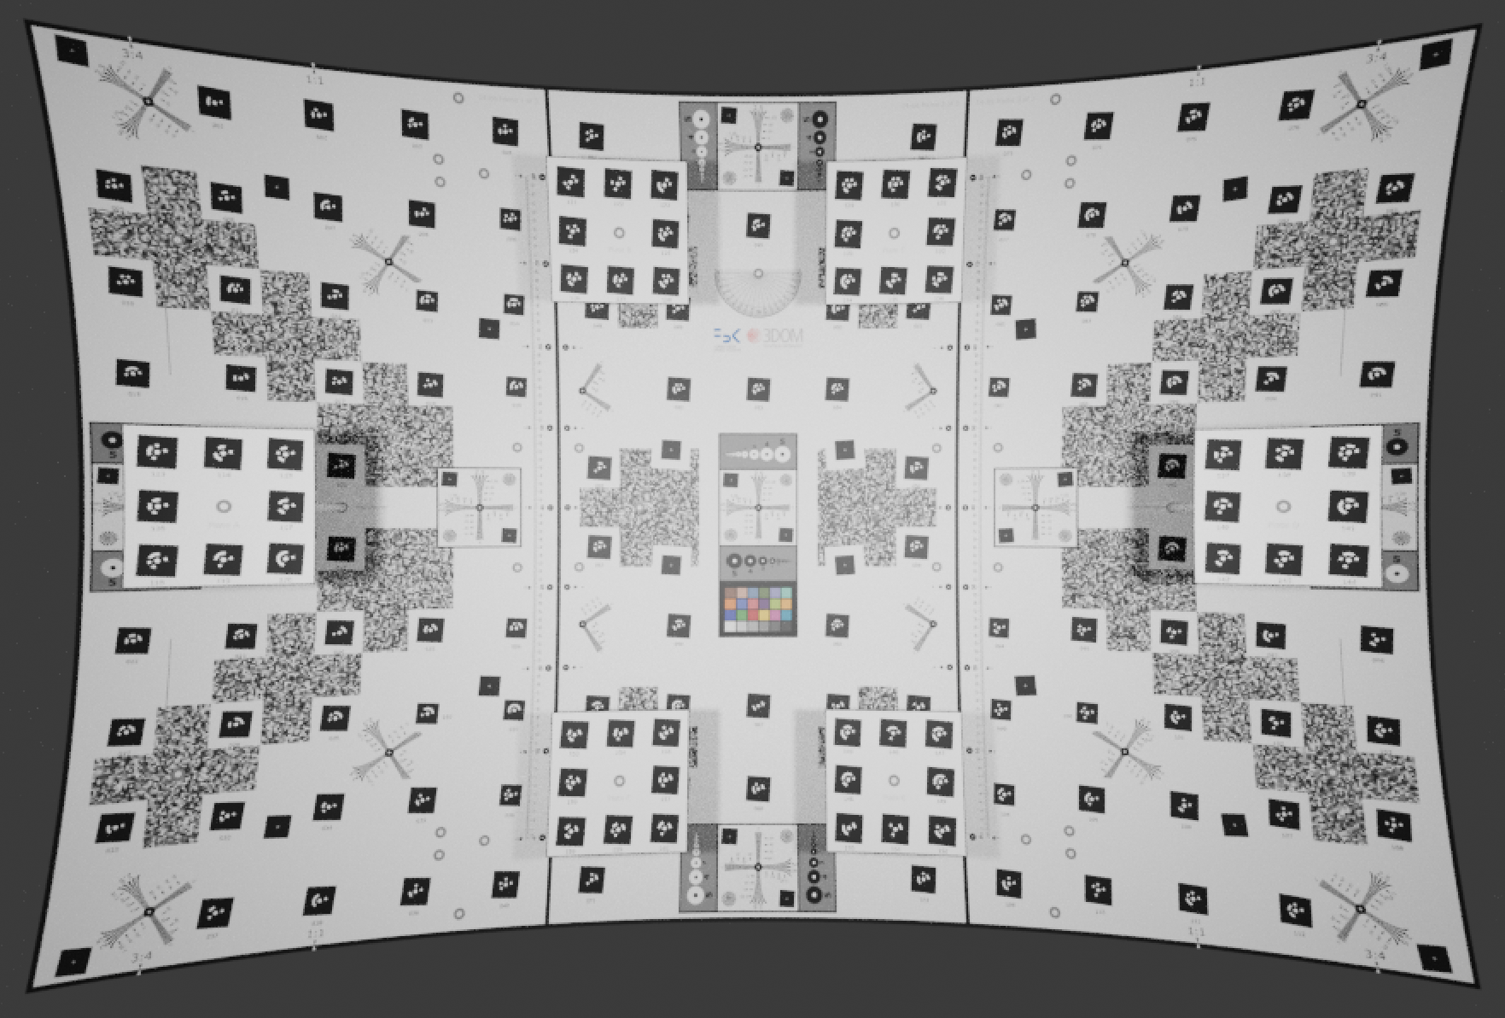 | 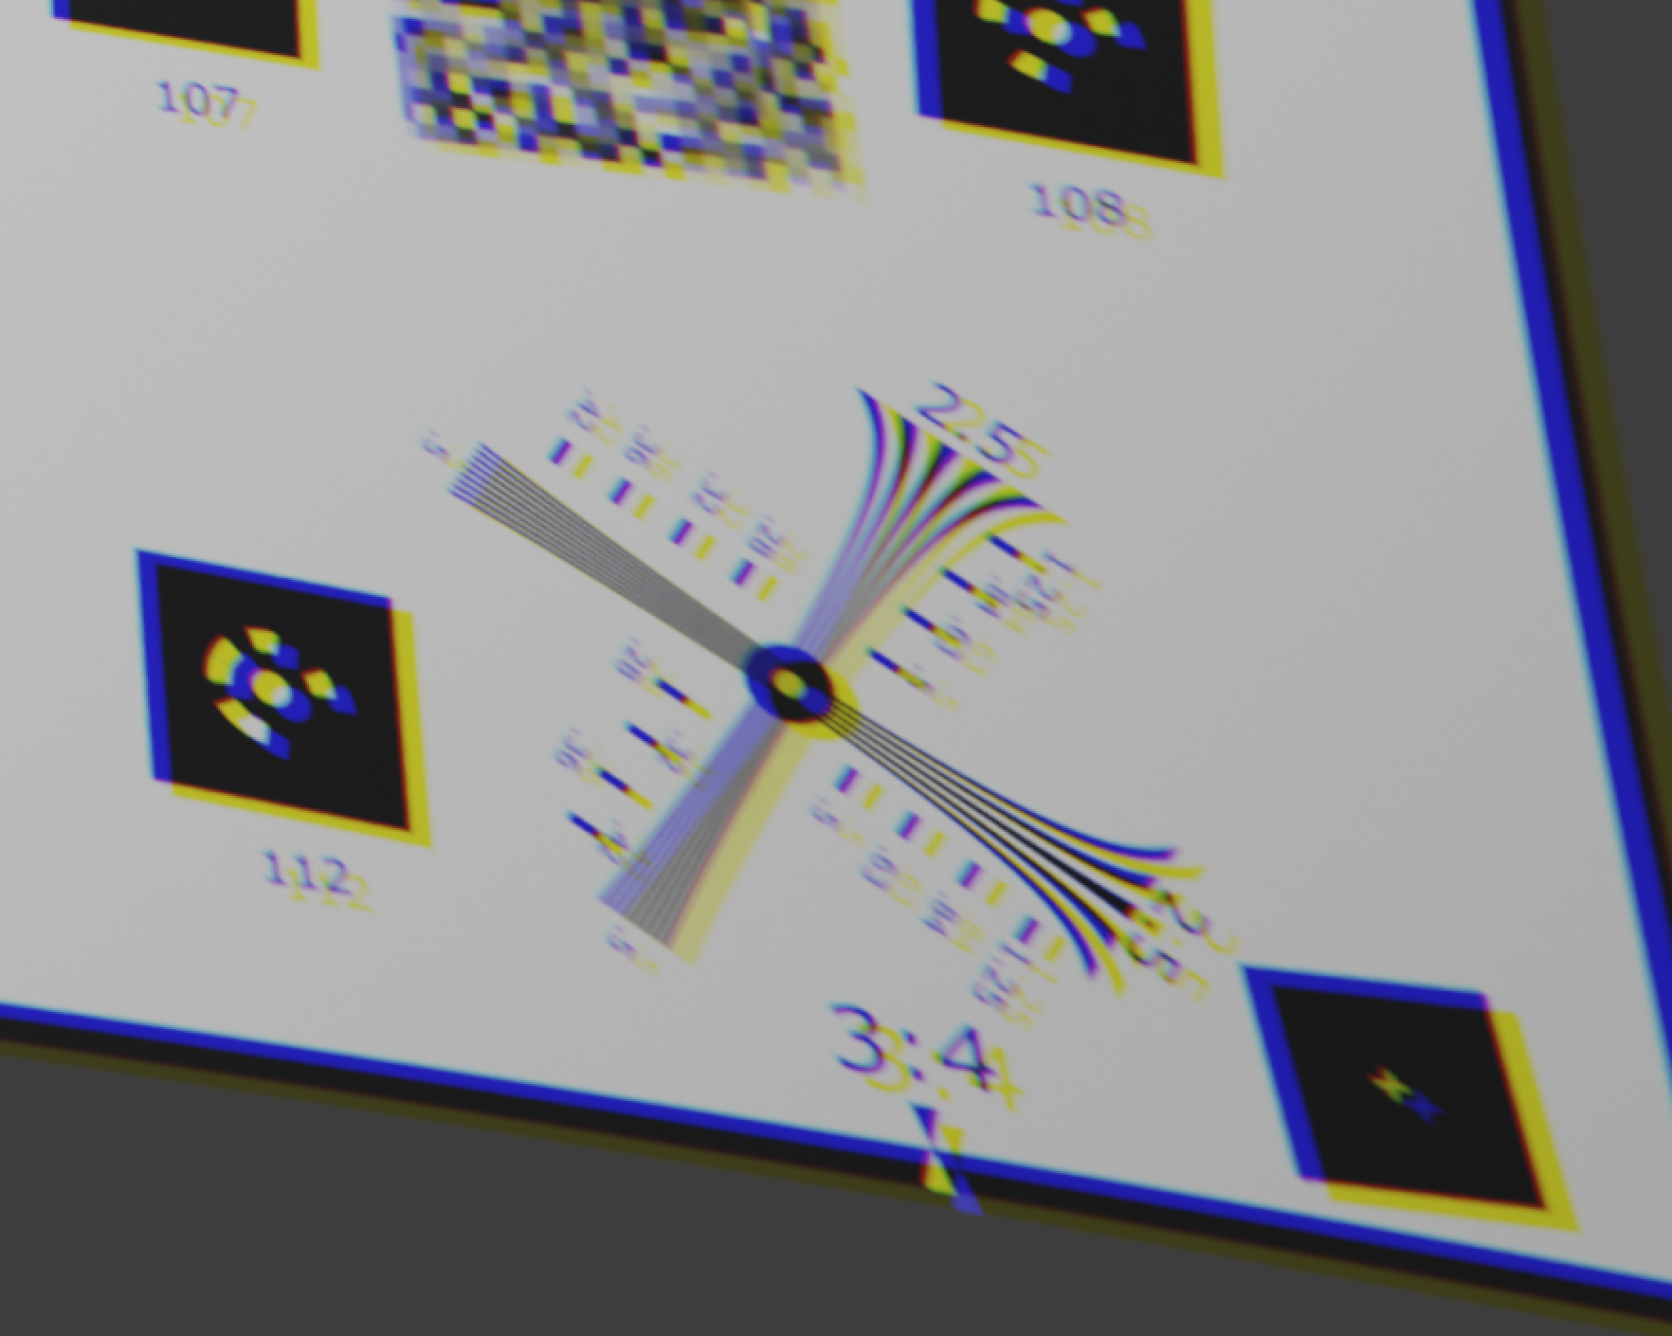
 | Camera-to-object distance 1.3m, EP 3cm from the inner surface of the flat.  Flat thickness of about 15mm |  | Corner unsharpness due to astigmatism. Strong chromatic aberrations visible
Dome (EP uncentered  Backward) | 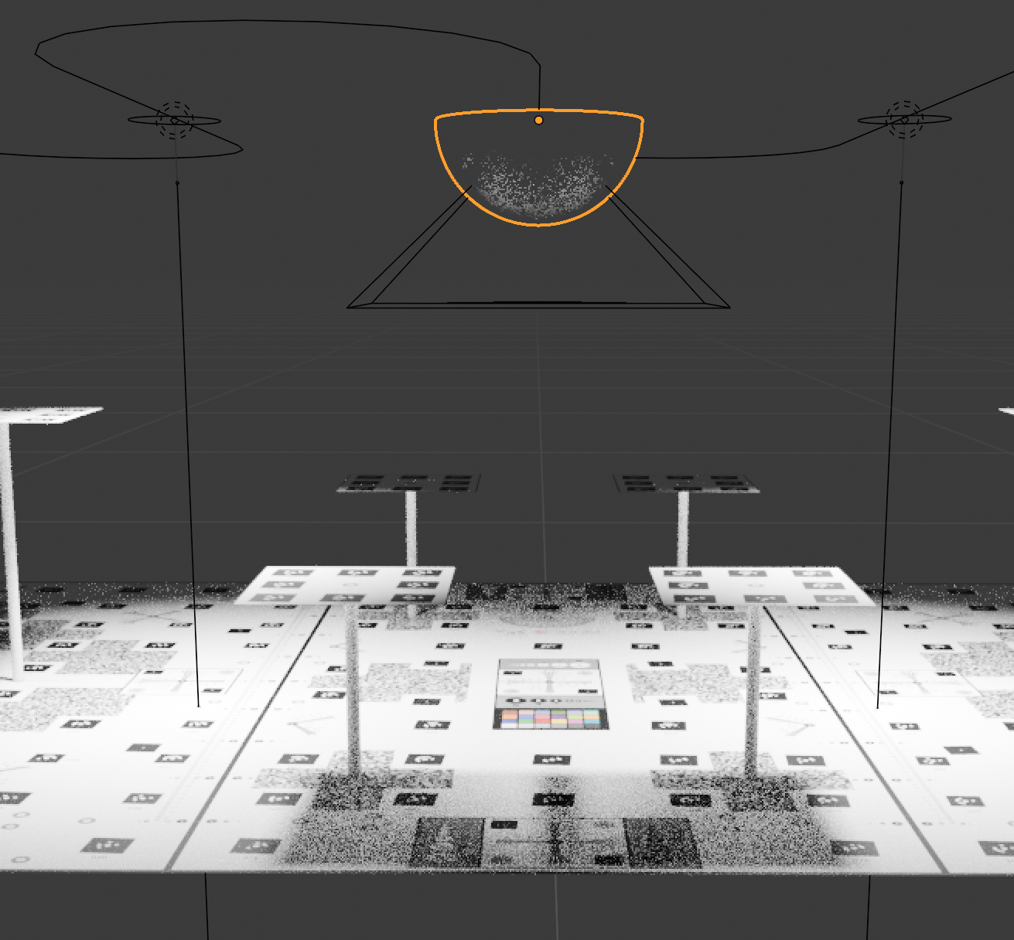 | 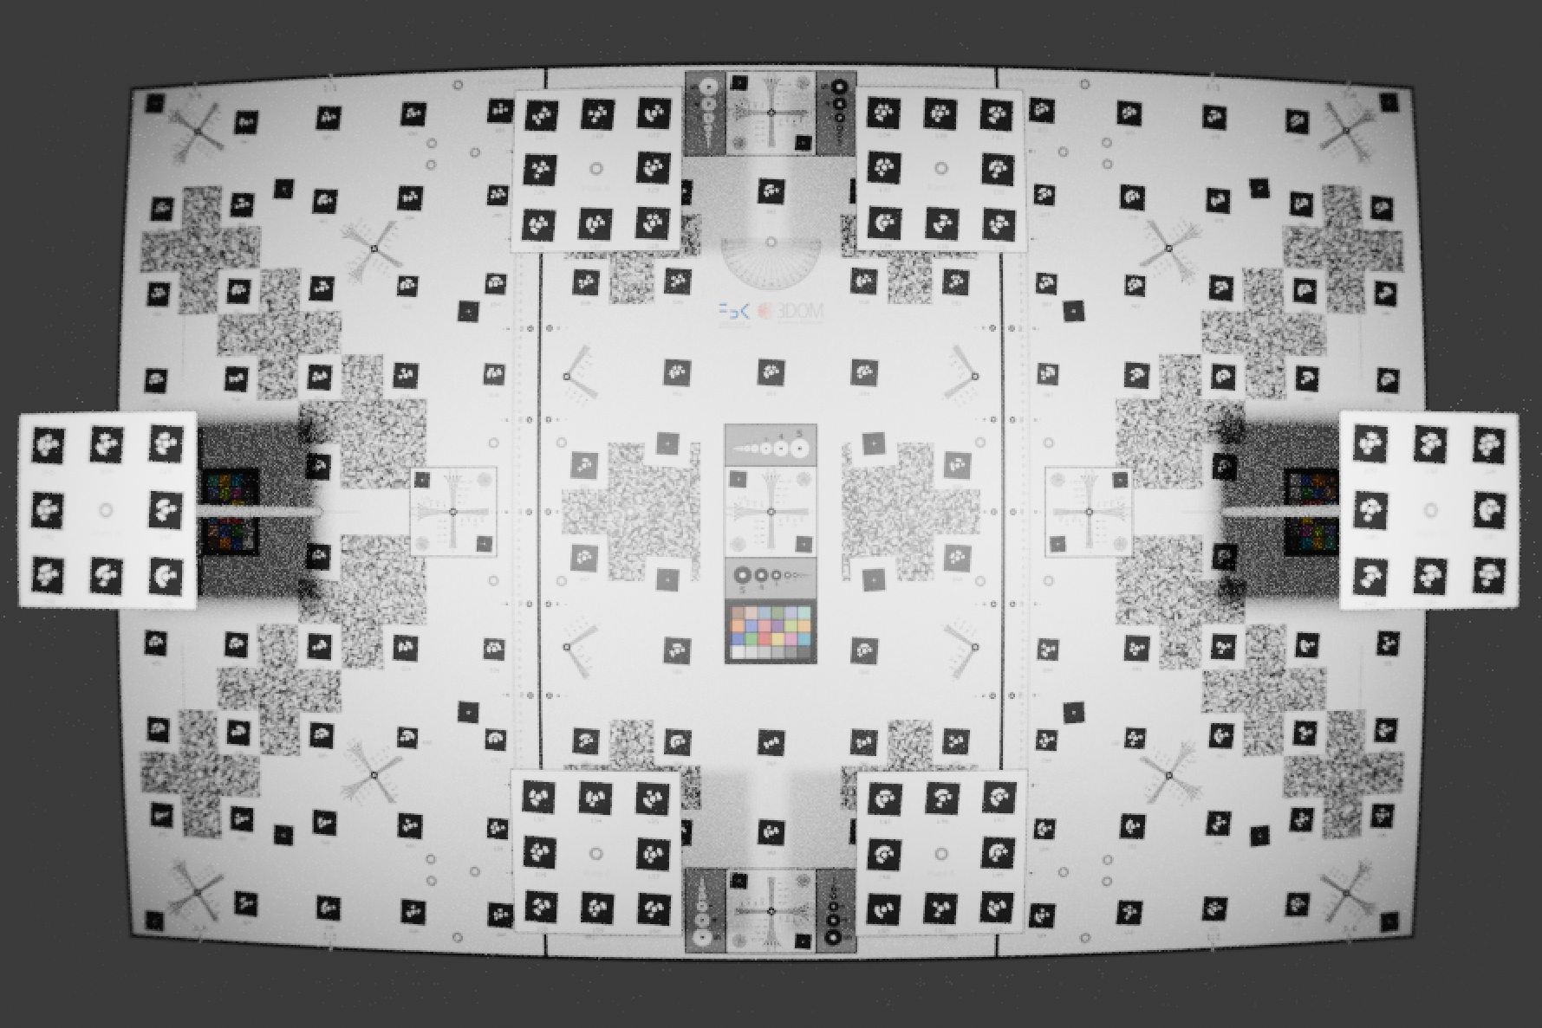 | 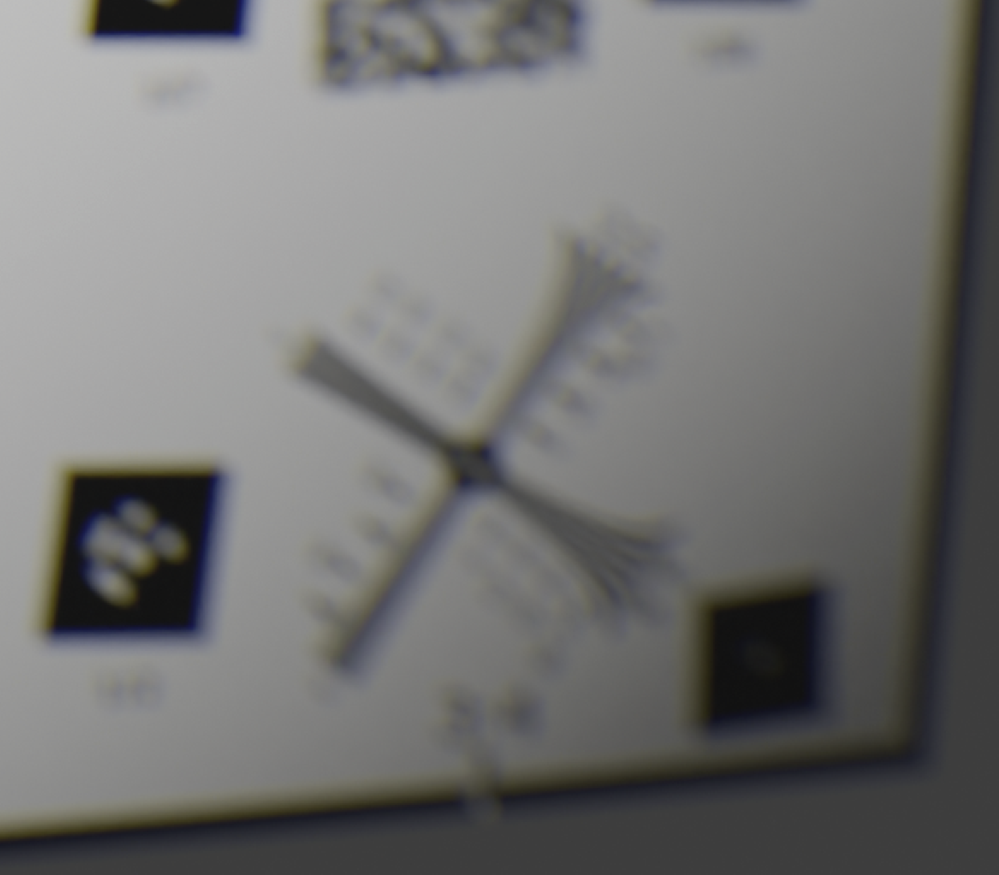
 | Camera-to-object distance 0.75m. EP backward longitudinal misalignment 5cm. Dome port inner radius 7cm thickness 1 cm |  | Corner unsharpness due to field curvature
Cylinder (EP off-axis forward) | 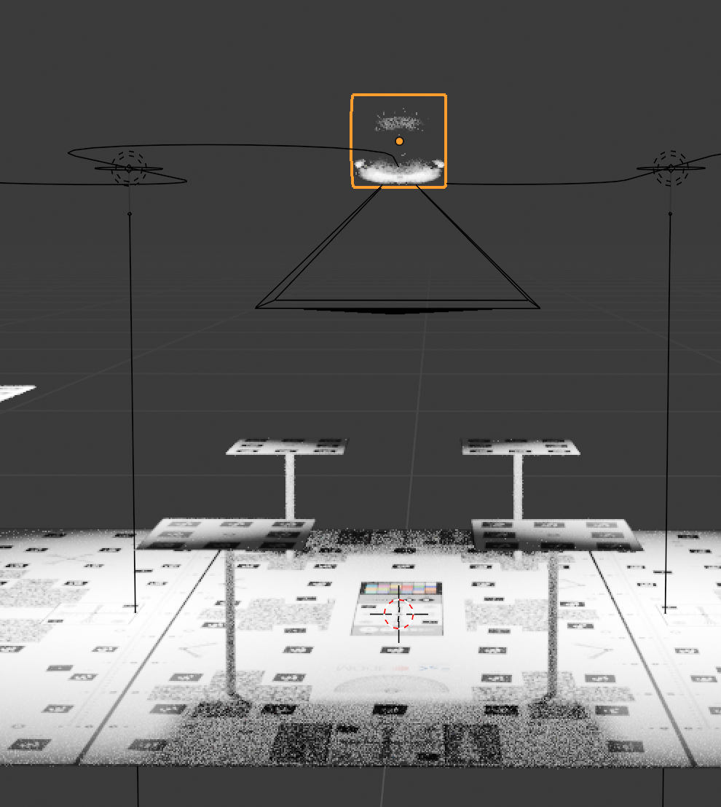 | 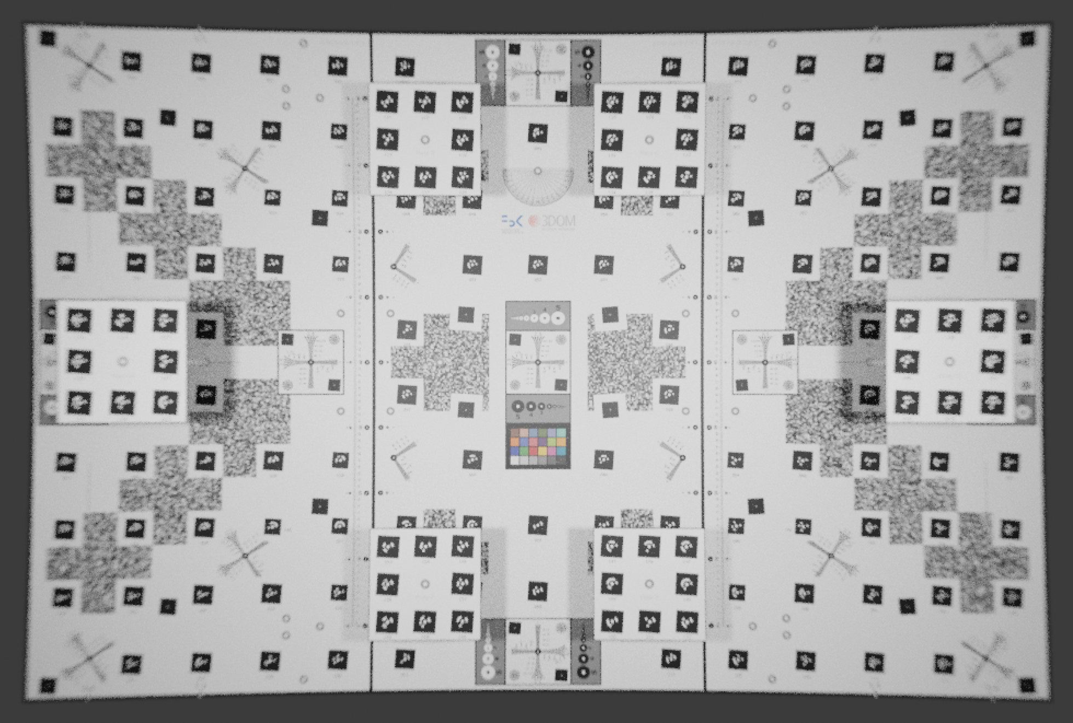 | 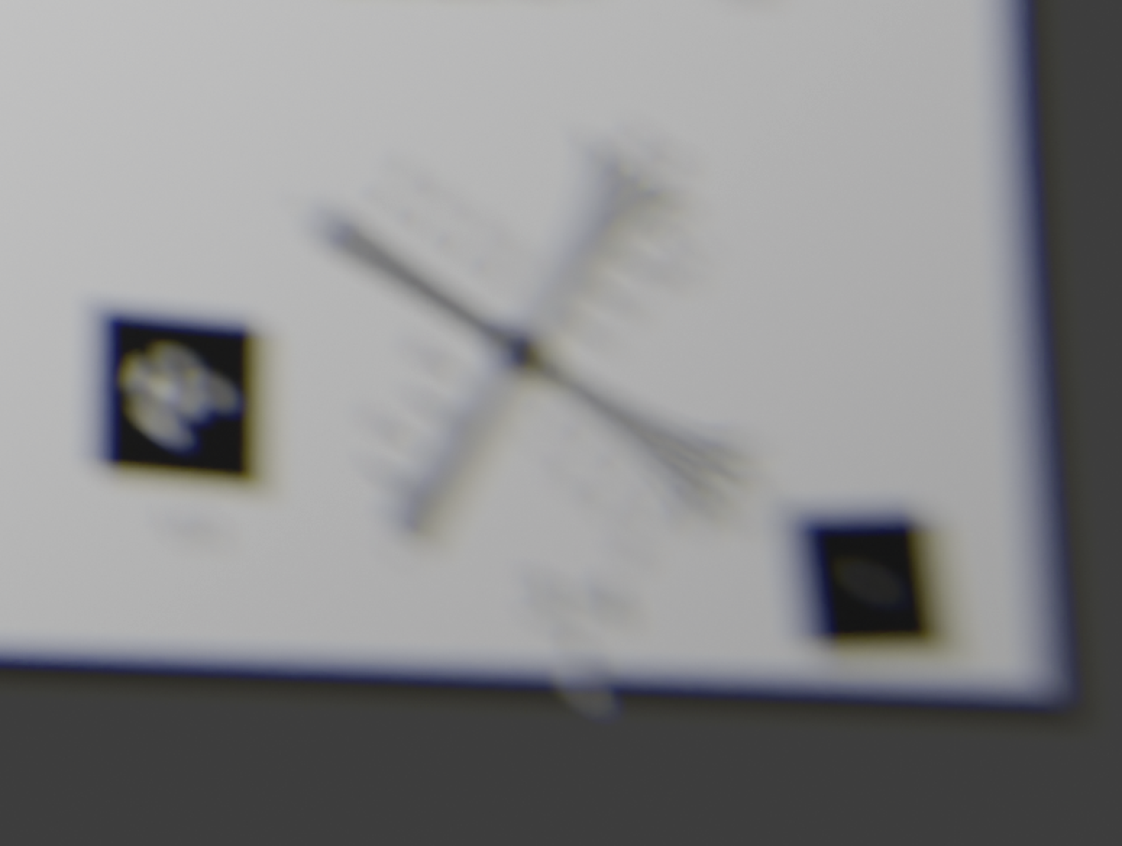
 | Camera-to-object distance 1.3m. Cylinder inner radius 5 cm, thickness 1 cm. EP off the cylinder axis with EP about 2 cm from the inner surface |  | Corner unsharpness from field curvature and astigmatism. Chromatic aberrations visible
Figure 5. The figure reports technical information on the setup and entrance pupil (EP) position.

Water caustics are created by sunlight reaching and refracting at the water surface or on highly reflective walls and submerged bottoms. In some cases, artificial lighting, both immersed or emersed, can also be the source of such a phenomenon, for example, when surveying a semi-submerged cave (Nocerino et al., 2019). In POSER, the water caustics are generated using the physical-based ocean modifier and random voronoi textures, visible as temporally changing light patterns on the object of interest.

Water turbidity and influence on image contrast
In survey planning for photogrammetry applications above the water, the amount of air between the camera and the subject is usually disregarded. On the contrary, this is an essential aspect in underwater photogrammetry, where light absorption and scattering have a major impact on the image contrast with respect to imaging in air, thus effectively reducing the spatial resolution of the images (i.e., the ability to discern between adjacent image points without them being coalesced) and the image observation accuracy (Codevilla et al., 2015; Garcia and Gracias 2011).
Moreover, the selective distant-dependent color absorption introduces color distortions (Jaffe, 1990) and strong color casts typically varying from blue (tropical waters) to green (lakes).
Using the volumetric rendering in Blender for scattering and absorption, the user can include scatter, backscattering, and water-selective color absorption. Figure 6 shows the underwater test-object illuminated by two LED lights at about 30cm on each side of the camera in a scene simulating green water like those typically encountered in lakes.

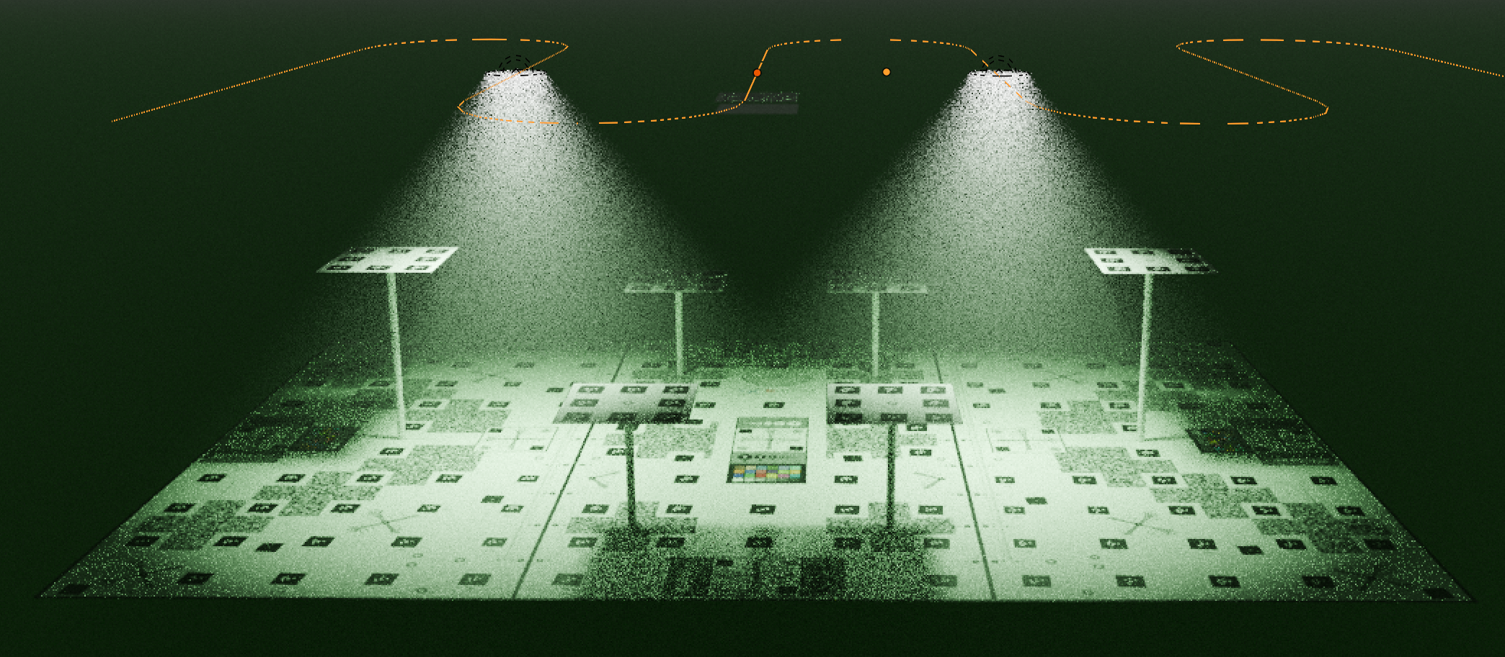 | 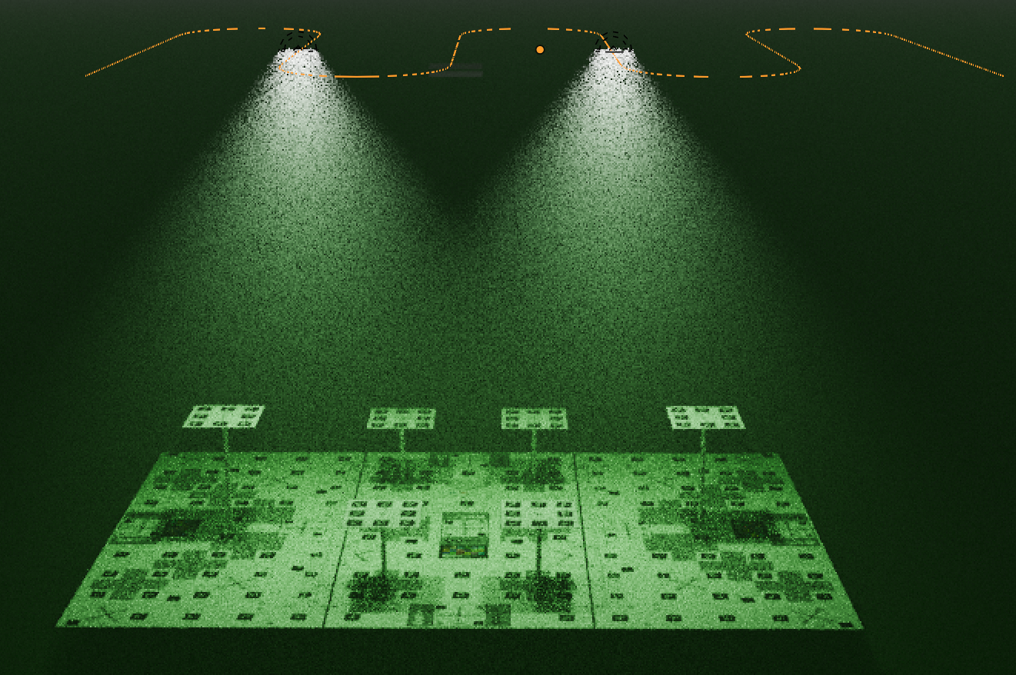
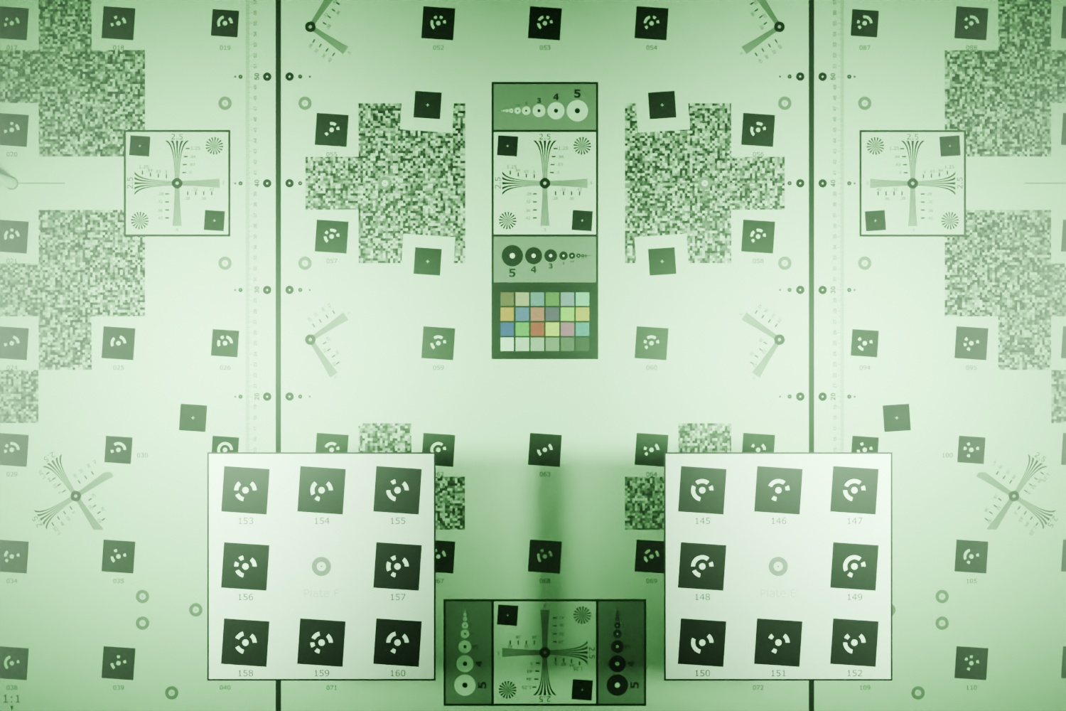 | 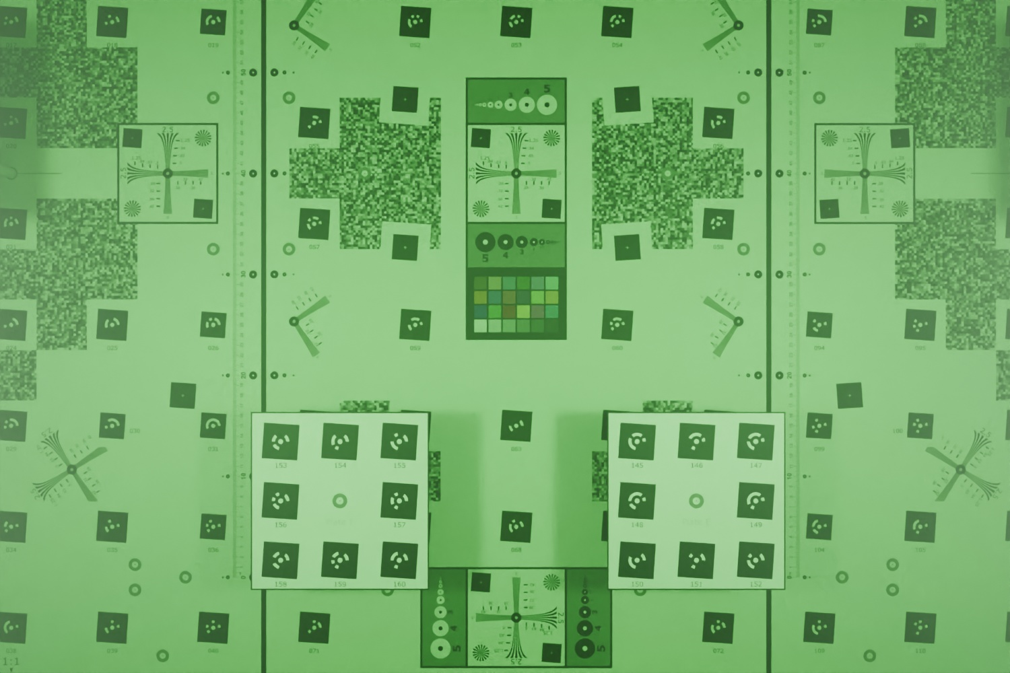
Figure 6
Two setups are considered giving the same ground sample distance, but the one on the left is taken with a wide-angle lens, while the one on the right uses a longer focal length that requires the camera to be more distant from the test-object.
The longer distance implies more water, and, consequently scattering volume between the camera and the subject, thus resulting in an image with less contrast and more intense color dominant given by the wavelength selective absorption.

LEARNING BY DOING WITH POSER
Simulation-based learning is generally understood to have significant positive effects on the acquisition of new complex skills (Chernikova 2020). Simulations can help to deliver experiences and meaningful examples in a scalable way, which can more easily translate from abstract theory to practical application within real world environments.

Within the POSER simulator, exemplified scenarios with case studies derived from real projects in marine archaeology, ecology and subsea metrology are envisaged. For each topic, an ad-hoc Blender project file is designed and prepared. Hereafter some examples of possible topics are reported.

Imaging basics in underwater photogrammetry
One of the first fundamental concepts taught in photogrammetry classes is the image scale and how it affects the level of details visible in the recorded scene as a function of the characteristics of the imaging sensor, lens, and distance from the subject. The ground sample distance is then defined as the pixel size expressed in ground (object space) units (Granshaw, 2020). Figure 3 shows an example of a 3D model of a French Polynesian coral reef from the Moorea Idea Project (Nocerino et al., 2020) that will be released within the POSER simulator. Although a pretty simple and intuitive concept, it can be difficult for beginners to understand how to choose between a camera sensor and lens properly, adapt the distance D to achieve a specific GSD, and how this affects the final 3D reconstruction. This example is an introductory exercise where the students compute the correct camera height from the sea bottom, given its focal length and pixel size, to meet a specific GSD, namely 1 and 3 mm in the figure. Precompiled blender file examples where the scene is already loaded will be released. The student can interactively modify the camera distance from the reef and check the achieved GSD using the metric resolution targets spread on the underwater scene. Besides understanding the level of detail associated with a specific GSD, this exercise fosters the good practice of having reference control and validation methods in the scene to quickly verify the captured data directly on-site.

Underwater camera calibration
The students can practice the concepts behind camera calibration using different calibration objects, from the planar checkerboard to the 3D test-object shown in Figure 1. The student can analyse the image quality of the specific system used (dome, flat, cylindrical ports) and design and test the impact of the camera network on the determinability and accuracy of interior and additional calibration parameters.

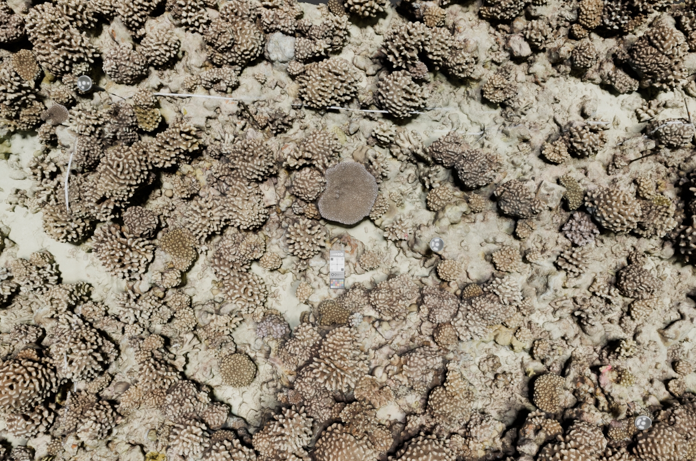

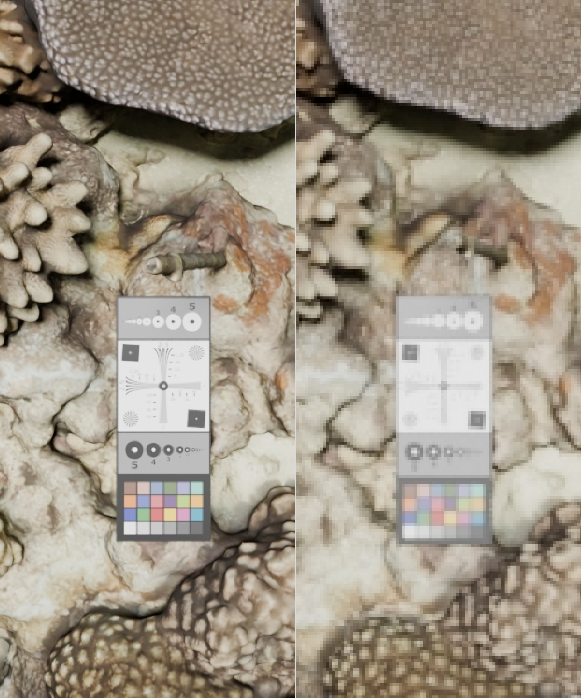
GSD: 1mm | GSD: 3mm
Figure 7

Accuracy degradation due to unmodelled refractive effects
The presence of a flat port (or an uncentered dome port) introduces systematic errors which grow with increasing EP offset from the flat port (or dome port center). To let the users to experiment with this critical concept, an exercise is prepared in POSER where a wide-angle lens (18mm full frame equivalent) is mounted behind a flat port (EP 3cm off the flat). About 2500 nadir images are simulated over a 55x7 m² plot (figure 8). The SfM + MVS with camera self-calibration performed in Metashape results in a deflected shape of the reef with errors in the range ±0.5m for the presence of the unmodelled systematic errors (figure 8) in a pure nadir network without oblique images (Nocerino et al., 2014; Menna et al 2020; James and Robson, 2014).

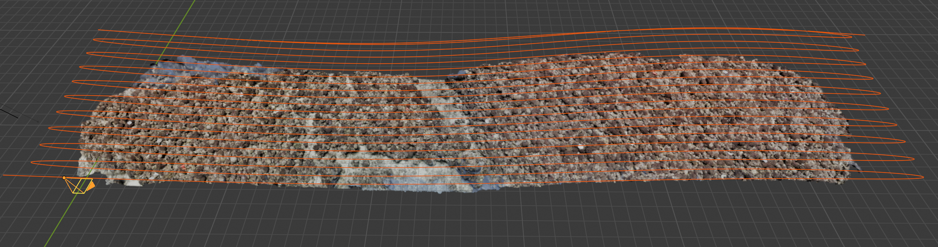
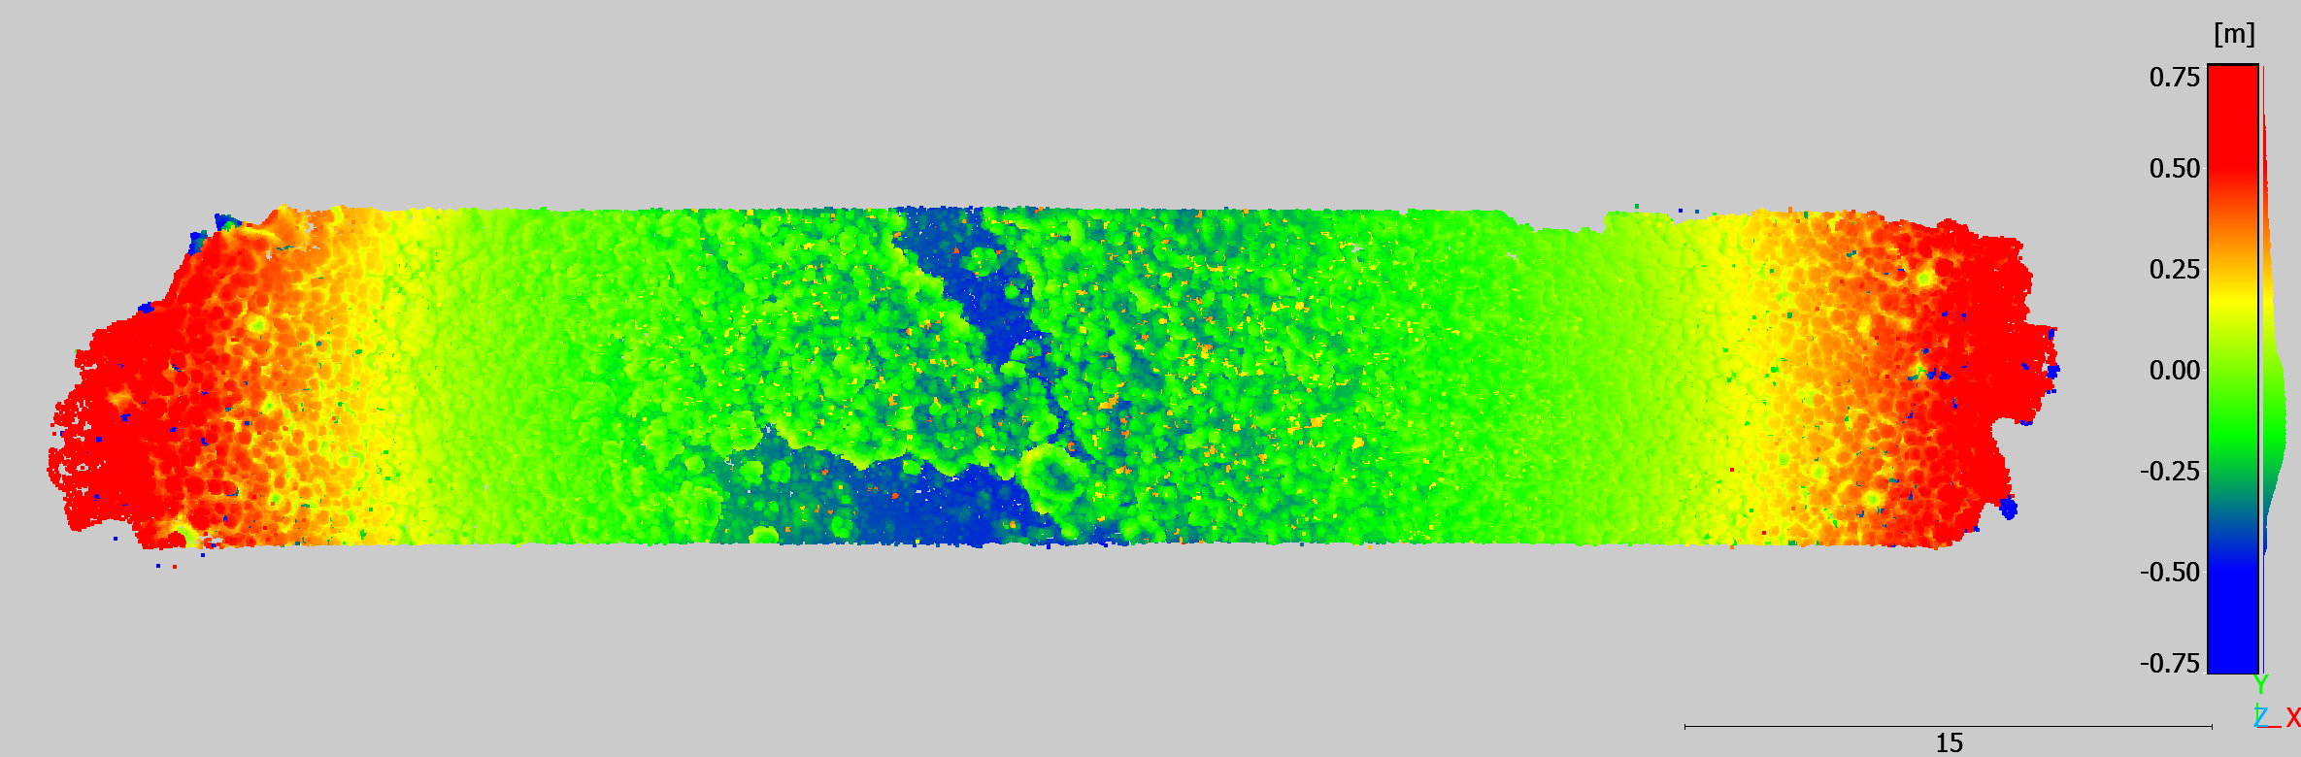
Figure 8. Flat port with nadir network

Refraction by waves and water caustics in underwater and through water applications
POSER can simulate underwater scenarios with caustics both under and through water, when the camera acquires images from above the water surface as when surveying in shallow clear water using an UAV. The students can practice with the challenges of orienting the simulated images with different wave heights, depths and visibility conditions and test different algorithms for caustics removal (Agrafiotis et al., 2023), and feature extraction and matching, from traditional to deep learning ones (Morelli et al, 2024; ).

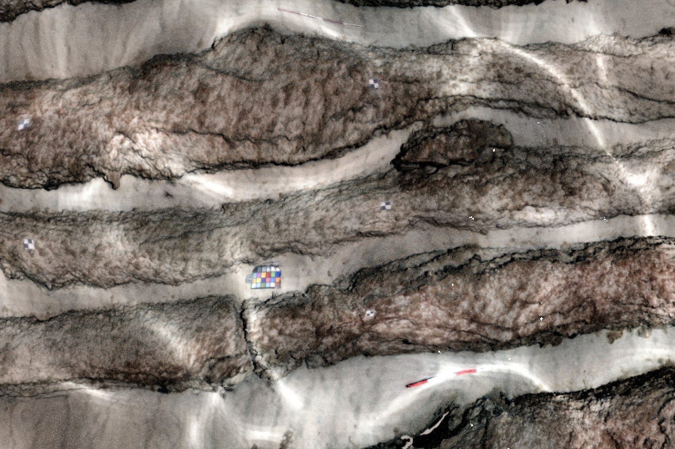
Through water

SCUBA diver operated surveys: training the safety of diving during underwater photogrammetry surveys
Due to the increased pressure underwater, inert gases in the breathed mix dissolve in the body tissues proportionally to the surrounding pressure. As long as the diver remains at the increased pressure for a time less than the so called non decompression limit (NDL), an ascent to the surface at a slow ascent rate (i.e. less than 9m/min) is always possible and presents minimal decompression sickness risks (DCS). The NDL reduces significantly with the pressure with only 10 minutes available at 40m depth without decompression obligations with respect to about 90 minutes available at 15m depth. 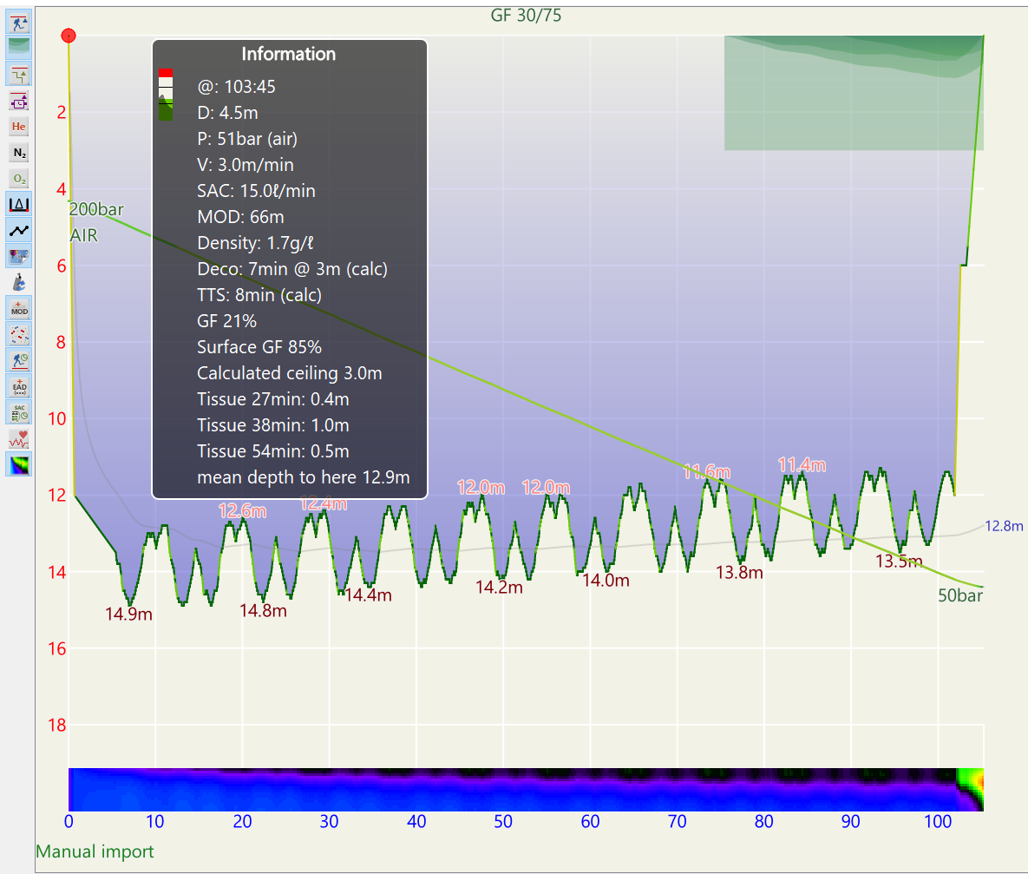

Moreover the breathed gas contained in the tank provides only a limited dive duration. For example, with a standard surface air consumption rate (SAC) of 20l/min, a diver can stay about 15 minutes at a depth of 40m or 45 minutes at a depth of 15m. Through python API, we enable the export of the dive profile associated to the simulated pathways in POSER needed to carry out a specific camera network. These can be imported in dive logging software applications, such as the open source free software Subsurface . This would allow for further analyses of the dive profile, including verification that the planned dive is safe both in terms of DCS and sufficient breathing gas. Figure 8 shows an example of a real 55x7m² reef area in Moorea surveyed by underwater photogrammetry. In the simulated survey 20 parallel strips for a total length of the path of about 1100 m are to be carried out at a depth of about 15m with a swimming speed of about 0.2 m/s. The resulting dive of about 104 minutes and its profile are analyzed in Subsurface dive log (figure xx), revealing decompression obligations and indicating the need for a larger volume tank (double 12l tan, SAC 15 l/mink) to carry out the survey in a single dive.

Conclusions
This paper introduced POSER, an oPen sOurce Simulation platform for tEaching and tRaining underwater photogrammetry. Funded by the ISPRS Educational and Capacity Building Initiatives, its main aim is to provide the scientific community with an easy-to-use, yet scientifically sound, platform to learn the fundamental of underwater photogrammetry and train with main challenges encountered in surveying operational practice.
The paper presented the main aspects of the project, motivating the decision to use Blender as a development platform and describing how critical water properties, such as refraction, light absorption and dropoff, are incorporated. To foster a learning-by-doing approach, we are designing and developing several ready-to-use application scenarios. The users are expected to experiment with different photogrammetric acquisition strategies, including single, stereo and multi-camera rigs, and test their influence on the attainable accuracy, also critically reasoning with the distribution of control and scaling elements, such as scale bars and markers. One additional feature we are working on is the possibility of integrating simulation outputs into dive logging software packages to practice with safe SCUBA dive planning.
Although POSER’s primary purpose is education and training, it is worth emphasizing the great potential also in terms of research and experimentation that such a platform can offer the community.
We are currently working on expanding the 3D datasets incorporated into POSER. These datasets may be also sourced, from the 2023 ISPRS NAUTILUS project, and, at the same time, datasets created with POSER may contribute to the NAUTILUS web portal. We foresee that the POSER simulator will be used as teaching support in ISPRS related underwater photogrammetry events such as tutorials and summer schools (Balletti et al., 2023). As future development, POSER’s team will work towards the possibility of trainers integrating their datasets to cover the specific teaching aspects they want to cover in their classes.

Acknowledgements

The authors wish to thank the partners of the UnderwaterMuse project and the team DIRECT of Politecnico di Torino for partial financial support in acquiring the archaeological case study (columns dataset).
This project has received funding from the ISPRS Education and Capacity Building Initiatives 2024.

References
Aristidou, K. and Michael, D., 2014. Towards building a diving simulator for organizing dives in real conditions. WSCG2014 Conference on Computer Graphics, Visualization, and Computer Vision.

Balletti, C., Capra, A., Calantropio, A., Chiabrando, F., Colucci, E., Furfaro, G., Guastella, A., Guerra, F., Lingua, A., Matrone, F., Menna, F., Nocerino, E., Teppati Losè, L., Vernier, P., and Visintini, D., 2023. The sunrise summer school: an innovative learning-by-doing experience for the documentation of archaeological heritage, Int. Arch. Photogramm. Remote Sens. Spatial Inf. Sci., XLVIII-M-2-2023, 147–154.

Bryson, M., Johnson-Roberson, M., Pizarro, O., & Williams, S. B. (2013). Colour-consistent structure-from-motion models using underwater imagery. Robotics: Science and Systems, 8, 33–40. https://doi.org/10.7551/mitpress/9816.003.0010

Calantropio, A., Chiabrando, F., and Auriemma, R.: Photogrammetric Underwater And Uas Surveys Of Archaeological Sites: The Case Study Of The Roman Shipwreck Of Torre Santa Sabina, Int. Arch. Photogramm. Remote Sens. Spatial Inf. Sci., XLIII-B2-2021, 643–650, https://doi.org/10.5194/isprs-archives-XLIII-B2-2021-643-2021, 2021.
Chernikova, O., Heitzmann, N., Stadler, M., Holzberger, D., Seidel, T., & Fischer, F. (2020). Simulation-Based Learning in Higher Education: A Meta-Analysis. Review of Educational Research, 90(4), 499-541. https://doi.org/10.3102/0034654320933544

Codevilla, F., Gaya, J.D., Duarte Filho, N. and Botelho, S.S., 2015, June. Achieving Turbidity Robustness on Underwater Images Local Feature Detection. In BMVC (Vol. 26, p. 157).

Garcia, R. and Gracias, N., 2011, June. Detection of interest points in turbid underwater images. In OCEANS 2011 IEEE-Spain (pp. 1-9). IEEE

Giuseffi, L. (2020). Using Technology to Improve Conservation: Virtual Environments for Testing Actionable Metrics of Scientific Methodology for Measuring Coral Recruits in the Field. UC San Diego: Center for Marine Biodiversity and Conservation. Retrieved from https://escholarship.org/uc/item/6hp3946d

Granshaw, S.I., 2020. Photogrammetric terminology. The Photogrammetric Record, 35(170), pp.143-288.

Floor, J. A., 2005. Water and Light in Underwater Photography.
http://www.seafriends.org.nz/phgraph/water.htm

Jaffe, J. S. (1990). Computer modeling and the design of optimal underwater imaging systems. IEEE Journal of Oceanic Engineering, 15(2), 101–111. https://doi.org/10.1109/48.50695

Luhmann, T., Chizhova, M., Gorkovchuk, D., Popovas, D., Gorkovchuk, J. and Hess, M., 2022. Development of terrestrial laser scanning simulator. The International Archives of the Photogrammetry, Remote Sensing and Spatial Information Sciences, 46, pp.329-334.

Mangeruga, M., Casavola, A., Pupo, F. and Bruno, F., 2020. An underwater pathfinding algorithm for optimised planning of survey dives. Remote Sensing, 12(23), p.3974.

Menna, F., Nocerino, E., Fassi, F. and Remondino, F., 2016. Geometric and optic characterization of a hemispherical dome port for underwater photogrammetry. Sensors, 16(1), p.48.

Menna, F., Nocerino, E. and Remondino, F., 2017, June. Optical aberrations in underwater photogrammetry with flat and hemispherical dome ports. In Videometrics, Range Imaging, and Applications XIV (Vol. 10332, pp. 28-41). SPIE.

Menna, F., Nocerino, E., Ural, S. and Gruen, A., 2020. Mitigating image residuals systematic patterns in underwater photogrammetry. The International Archives of the Photogrammetry, Remote Sensing and Spatial Information Sciences, 43, pp.977-984.

Morel, A. (1974). Optical properties of pure water and pure sea water.

Morelli, L., Ioli, F., Maiwald, F., Mazzacca, G., Menna, F. and Remondino, F., 2024. Deep-image-matching: a toolbox for multiview image matching of complex scenarios. The International Archives of the Photogrammetry, Remote Sensing and Spatial Information Sciences, 48, pp.309-316.

Nakath, D., She, M., Song, Y. and Köser, K., 2022. An Optical Digital Twin for Underwater Photogrammetry: GEODT—A Geometrically Verified Optical Digital Twin for Development, Evaluation, Training, Testing and Tuning of Multi-Media Refractive Algorithms. PFG–Journal of Photogrammetry, Remote Sensing and Geoinformation Science, 90(1), pp.69-81.

Nocerino, E., Menna, F. and Remondino, F., 2014. Accuracy of typical photogrammetric networks in cultural heritage 3D modeling projects. The international archives of the photogrammetry, remote sensing and spatial information sciences, 40, pp.465-472.

Nocerino, E., Menna, F., Farella, E. and Remondino, F., 2019. 3D virtualization of an underground semi-submerged cave system. The International Archives of the Photogrammetry, Remote Sensing and Spatial Information Sciences, 42, pp.857-864.

Nocerino, E., Menna, F. and Grün, A., 2021. Bundle adjustment with polynomial point-to-camera distance dependent corrections for underwater photogrammetry. The International Archives of the Photogrammetry, Remote Sensing and Spatial Information Sciences, 43, pp.673-679.

Nocerino, E., Menna, F., Gruen, A., Troyer, M., Capra, A., Castagnetti, C., Rossi, P., Brooks, A.J., Schmitt, R.J. and Holbrook, S.J., 2020. Coral reef monitoring by scuba divers using underwater photogrammetry and geodetic surveying. Remote Sensing, 12(18), p.3036.

Rofallski, R., Menna, F., Nocerino, E. and Luhmann, T., 2022. An efficient solution to ray tracing problems for hemispherical refractive interfaces. ISPRS Annals of the Photogrammetry, Remote Sensing and Spatial Information Sciences, 2, pp.333-342.

She, M., Nakath, D., Song, Y. and Köser, K., 2022. Refractive geometry for underwater domes. ISPRS Journal of Photogrammetry and Remote Sensing, 183, pp.525-540.

Wang, J., Zhou, Y., Li, B., Meng, Q., Rocco, E. and Saiani, A., 2019. Can underwater environment simulation contribute to vision tasks for autonomous systems? Presented at the 2nd UK Robotics and Autonomous Systems Conference, (UK-RAS 2019), Loughborough University, 24th January.

Zwilgmeyer, P.G.O., Yip, M., Teigen, A.L., Mester, R. and Stahl, A., 2021. The varos synthetic underwater data set: Towards realistic multi-sensor underwater data with ground truth. In Proceedings of the IEEE/CVF international conference on computer vision (pp. 3722-3730).

https://www.deeptrekker.com/
https://subsurface-divelog.org/
https://nautilus-isprs.fbk.eu/
https://nautilus-isprs.fbk.eu/dataset-collection/nautilus-web-portal

